UNITED STATES
SECURITIES AND EXCHANGE COMMISSION
WASHINGTON, D.C. 20549

FORM 8-K

CURRENT REPORT
Pursuant to Section 13 or 15(d)
of the Securities Exchange Act of 1934
Date of report (Date of earliest event reported): September 29, 2026

Dyne Therapeutics, Inc.
(Exact Name of Registrant as Specified in Charter)

Delaware | 001-39509 | 36-4883909
(State or Other Jurisdiction  of Incorporation) | (Commission  File Number) | (IRS Employer  Identification No.)
1560 Trapelo Road  Waltham, Massachusetts |  | 02451
(Address of Principal Executive Offices) |  | (Zip Code)

Registrant’s telephone number, including area code: (781) 786-8230
Not applicable
(Former Name or Former Address, if Changed Since Last Report)

Check the appropriate box below if the Form 8-K filing is intended to simultaneously satisfy the filing obligation of the registrant under any of the following provisions (see General Instruction A.2. below):
☐ | Written communications pursuant to Rule 425 under the Securities Act (17 CFR 230.425)
☐ | Soliciting material pursuant to Rule 14a-12 under the Exchange Act (17 CFR 240.14a-12)
☐ | Pre-commencement communications pursuant to Rule 14d-2(b) under the Exchange Act (17 CFR 240.14d-2(b))
☐ | Pre-commencement communications pursuant to Rule 13e-4(c) under the Exchange Act (17 CFR 240.13e-4(c))
Securities registered pursuant to Section 12(b) of the Act:

Title of each class |  | Trading symbol(s) |  | Name of each exchange on which registered
Common stock, $0.0001 par value per share |  | DYN |  | Nasdaq Global Select Market

Indicate by check mark whether the registrant is an emerging growth company as defined in Rule 405 of the Securities Act of 1933 (§230.405 of this chapter) or Rule 12b-2 of the Securities Exchange Act of 1934 (§240.12b-2 of this chapter).
Emerging growth company ☐
If an emerging growth company, indicate by check mark if the registrant has elected not to use the extended transition period for complying with any new or revised financial accounting standards provided pursuant to Section 13(a) of the Exchange Act. ☐

Item 7.01 Regulation FD Disclosure.

On September 29, 2026, Dyne Therapeutics, Inc. (the “Company”) issued a press release and presentation announcing additional one-year clinical data from the multiple ascending dose (“MAD”) portion of its Phase 1/2 ACHIEVE clinical trial (the “ACHIEVE trial”) evaluating zeleciment basivarsen (z-basivarsen, also known as DYNE-101) for myotonic dystrophy type 1 (“DM1”). Additionally, the Company announced the mean baseline value for video hand-opening time (“vHOT”) for the participants enrolled in the registrational expansion cohort (“REC”) of the ACHIEVE trial. A copy of the press release and data presentation are furnished as Exhibit 99.1 and Exhibit 99.2 hereto respectively and are incorporated herein by reference.

The information furnished under this Item 7.01, including Exhibit 99.1 and Exhibit 99.2, shall not be deemed “filed” for purposes of Section 18 of the Securities Exchange Act of 1934, as amended (the “Exchange Act”), or otherwise subject to the liabilities of that section, nor shall it be deemed incorporated by reference in any filing under the Securities Act of 1933, as amended, or the Exchange Act, except as expressly set forth by specific reference in such a filing.
Item 8.01 Other Events.

On September 29, 2026, the Company issued a press release and presentation announcing additional one-year clinical data from the ACHIEVE trial evaluating z-basivarsen in individuals with DM1. The new data come from a pooled dose group of participants (N=25-26) from the 3.4 mg/kg every four weeks, 5.4 mg/kg every 8 weeks and 6.8 mg/kg every 8 weeks cohorts of the MAD portion of the ACHIEVE trial (the “pooled dose group”), including participants originally assigned to the placebo group (re-baselined to the visit prior to their first active dose). The pooled dose group includes a mixture of dose exposures and does not reflect the effect of maintaining the registrational dose of 6.8 mg/kg every 8 weeks for the entire treatment duration, as only 8 of 26 participants in the pooled dose group received the registrational dose for the full 12 months analyzed, and most did not receive the registrational dose during this timeframe. For certain measurements at 12 months, these data were compared to a cohort of participants (N=41-46) from the ongoing END-DM1 natural history study who were propensity-matched to the ACHIEVE pooled dose group (the “matched natural history cohort”).

These data include:

•
Myotonia: Sustained improvement from baseline in hand myotonia, as measured by vHOT. The pooled dose group had a mean baseline vHOT of 8.2 seconds, which decreased by 3.2 seconds at 6 months (standard deviation of change from baseline: 3.5 seconds). This is compared to an increase of 0.4 seconds in the placebo group from the ACHIEVE MAD at 6 months (N=14), representing a 3.6 second relative improvement. The change from baseline in vHOT at 6 months is the primary endpoint of the ACHIEVE REC, from which topline data are expected in the first quarter of 2027 to support a potential Biologics License Application (“BLA”) submission for U.S. Accelerated Approval in the third quarter of 2027.
•
Function: Sustained improvement from baseline in function, as assessed by the 5 times sit to stand (“5xSTS”) test and the 10-meter walk/run (“10MWR”) test. In the pooled dose group at 12 months, participants improved on 5xSTS by 1.2 seconds and on 10MWR by 0.3 seconds relative to baseline, showing a divergence from the matched natural history cohort on 10MWR. 5xSTS was not included in the END-DM1 natural history study, so no comparisons could be made. The change from baseline in 5xSTS at 12 months is the primary endpoint of the ongoing global Phase 3 HARMONIA clinical trial, which is intended to serve as a confirmatory trial for traditional approval in the U.S. and support ex-U.S. marketing applications.
•
Strength: Sustained improvement from baseline on muscle strength as assessed by the quantitative muscle testing (“QMT”) total score and the individual QMT hand grip score. In the pooled dose group at 12 months, participants improved on both QMT total and hand grip by 4.8% predicted relative to baseline, showing a divergence from the matched natural history cohort on both measures.
•
Patient Reported Outcomes: Sustained improvement from baseline in the Myotonic Dystrophy Health Index (“MDHI”) patient reported outcome measure, including in 6 subscales assessing central nervous system disease manifestations (cognitive impairment, sleep disturbances, fatigue, communication, emotional issues and pain). In the pooled dose group at 12 months, participants improved on the MDHI total score by 25.2% relative to baseline, showing a divergence from an unmatched END-DM1 natural

history cohort (N=410).
•
Safety and Tolerability: Updated safety and tolerability data as of April 20, 2026, from participants initially enrolled in the MAD portion of the ACHIEVE trial. Z-basivarsen continued to demonstrate a favorable safety profile, and no related serious treatment emergent adverse events were identified.

Additionally, the Company announced that the mean baseline value for vHOT of the 71 participants enrolled in the ACHIEVE REC is 8.3 seconds (standard deviation at baseline: 6.0 seconds). These baseline data remain blinded to treatment assignment. Topline data from the ACHIEVE REC, which is intended to support a potential application for U.S. Accelerated Approval, are planned for the first quarter of 2027.

Cautionary Note Regarding Forward-Looking Statements

This Current Report on Form 8-K contains forward-looking statements that involve substantial risks and uncertainties. All statements, other than statements of historical facts, contained in this Current Report on Form 8-K, including statements regarding the Company’s strategy, future operations, prospects and plans, objectives of management, the potential of the FORCE platform, the clinical potential of z-basivarsen and its potential to mitigate central nervous system-related manifestations of DM1, expectations regarding the timing and outcome of data from clinical trials, expectations regarding the timing and outcome of submissions to and interactions with global regulatory authorities, the availability of accelerated approval pathways for z-basivarsen, and the potential of video hand opening time to serve as an intermediate clinical endpoint for U.S. accelerated approval constitute forward-looking statements within the meaning of The Private Securities Litigation Reform Act of 1995. The words “anticipate,” “believe,” “continue,” “could,” “estimate,” “expect,” “intend,” “may,” “might,” “objective,” “ongoing,” “plan,” “predict,” “project,” “potential,” “should,” “will” or “would,” or the negative of these terms, or other comparable terminology are intended to identify forward-looking statements, although not all forward-looking statements contain these identifying words. The Company may not actually achieve the plans, intentions or expectations disclosed in these forward-looking statements, and you should not place undue reliance on these forward-looking statements. Actual results or events could differ materially from the plans, intentions and expectations disclosed in these forward-looking statements as a result of various important factors, including: uncertainties inherent in the identification and development of product candidates, including the initiation and completion of preclinical studies and clinical trials; uncertainties as to the availability and timing of results from preclinical studies and clinical trials; the timing of and the Company’s ability to enroll patients in clinical trials; whether results from preclinical studies and initial data from early clinical trials will be predictive of the final results of the clinical trials or future trials; uncertainties as to the FDA’s and other regulatory authorities’ interpretation of the data from the Company's clinical trials and acceptance of the Company's clinical programs and the regulatory approval process; whether the Company’s cash resources will be sufficient to fund its foreseeable and unforeseeable operating expenses and capital expenditure requirements; as well as the risks and uncertainties identified in the Company’s filings with the Securities and Exchange Commission (SEC), including the Company’s most recent Form 10-Q and in subsequent filings the Company may make with the SEC. In addition, the forward-looking statements included in this Current Report on Form 8-K represent the Company’s views as of the date hereof. The Company anticipates that subsequent events and developments will cause its views to change. However, while the Company may elect to update these forward-looking statements at some point in the future, it specifically disclaims any obligation to do so. These forward-looking statements should not be relied upon as representing the Company’s views as of any date subsequent to the date hereof.
Item 9.01 Financial Statements and Exhibits.
(d) Exhibits

Exhibit No. |  | Description
99.1 |  | Press Release, dated September 29, 2026
99.2 |  | Presentation, dated September 29, 2026
104 |  | Cover Page Interactive Data File (embedded within the Inline XBRL document)

SIGNATURES
Pursuant to the requirements of the Securities Exchange Act of 1934, as amended, the registrant has duly caused this report to be signed on its behalf by the undersigned hereunto duly authorized.

 |  | DYNE THERAPEUTICS, INC.
Date: September 29, 2026 |  | By: |  | /s/ Erick Lucera
 |  |  |  | Name: |  | Erick Lucera
 |  |  |  | Title: |  | Treasurer and Chief Financial Officer

Exhibit 99.1


Dyne Therapeutics Announces Additional One-Year Clinical Data from Phase 1/2 ACHIEVE Trial of Z-Basivarsen (DYNE-101) for Myotonic Dystrophy Type 1 (DM1)

- Data from a pooled dose group of participants initially enrolled in the multiple ascending dose (MAD) portion of ACHIEVE showed functional improvement versus baseline, versus placebo and versus a matched natural history cohort across multiple measures at 12 months -

- Data continued to support improvement at 6 months in video hand opening time (vHOT) as an early indicator of clinical benefit with z-basivarsen in DM1 -

- Dyne continues to expect topline data in Q1 2027 from the ACHIEVE registrational expansion cohort (REC), with a primary endpoint of change from baseline in vHOT at 6 months, intended to support a potential submission for U.S. Accelerated Approval in Q3 2027 -

- The mean baseline vHOT in the ACHIEVE REC is 8.3 seconds -

WALTHAM, Mass., Sept. 29, 2026 – Dyne Therapeutics, Inc. (Nasdaq: DYN), a clinical-stage company focused on delivering functional improvement for people living with genetically driven neuromuscular diseases, today announced additional one-year efficacy data from the MAD portion of its ongoing Phase 1/2 ACHIEVE clinical trial of zeleciment basivarsen (z-basivarsen, also known as DYNE-101) for DM1, showing functional improvement across multiple measures. These data are being presented at the 31st Annual International Congress of the World Muscle Society (WMS) being held September 29, 2026, through October 3, 2026, virtually and in Hiroshima, Japan, as well as the 2026 Annual Meeting of the American Association of Neuromuscular & Electrodiagnostic Medicine (AANEM) being held September 29, 2026, through October 2, 2026, virtually and in Orlando, Florida.

“This week we are presenting data at 6 and 12 months from a larger pooled dose group of participants from ACHIEVE, which further support our confidence in the results we have previously presented from smaller individual dose cohorts,” said Doug Kerr, M.D., Ph.D., chief medical officer of Dyne. “In addition, for the first time, we are showing functional improvement across multiple measures compared to a matched natural history cohort, not just compared to placebo and compared to baseline. We attribute these results to the differentiated properties of our FORCE platform and z-basivarsen, which is designed to correct the core underlying splicing abnormalities in DM1 by delivering a targeted therapeutic payload to the nucleus in both muscle and the CNS. We aim to confirm these findings through both the ACHIEVE REC and the Phase 3 HARMONIA study, which is currently recruiting participants at over 35 active global sites.”
The analyses being presented at WMS and AANEM were designed to evaluate whether a larger treated group showed the same positive efficacy trends previously observed in a smaller cohort of participants receiving the registrational dose of 6.8 mg/kg Q8W (N=6). Data from a pooled dose group of participants (N=25-26) from the 3.4 mg/kg Q4W, 5.4 mg/kg Q8W and 6.8 mg/kg Q8W cohorts of the MAD portion of the ACHIEVE trial, including participants originally assigned to the
1

placebo group (re-baselined to the visit prior to their first active dose), were assessed through 12 months of treatment.

The pooled dose group includes a mixture of dose exposures and does not reflect the effect of maintaining the registrational dose of 6.8 mg/kg for the entire treatment duration, as only 8 of 26 participants in the pooled dose group received the registrational dose for the full 12 months analyzed and most did not receive the registrational dose during this timeframe.

At 12 months, these data were compared to a cohort of participants (N=41-46) from the ongoing END-DM1 natural history study who were propensity-matched to the ACHIEVE pooled dose group.

The new results to be presented at WMS and AANEM include:

•
Myotonia: Sustained improvement from baseline in hand myotonia, as measured by vHOT. The pooled dose group had a mean baseline vHOT of 8.2 seconds, which decreased by 3.2 seconds at 6 months (standard deviation of change from baseline: 3.5 seconds). This is compared to an increase of 0.4 seconds in the placebo group from the ACHIEVE MAD at 6 months (N=14), representing a 3.6 second relative improvement. The change from baseline in vHOT at 6 months is the primary endpoint of the ACHIEVE REC, from which topline data are expected in Q1 2027 to support a potential Biologics License Application (BLA) submission for U.S. Accelerated Approval in Q3 2027.

•
Function: Sustained improvement from baseline in function, as assessed by the 5 times sit to stand (5xSTS) test and the 10-meter walk/run (10MWR) test. In the pooled dose group at 12 months, participants improved on 5xSTS by 1.2 seconds and on 10MWR by 0.3 seconds relative to baseline, showing a divergence from the matched natural history cohort on 10MWR. 5xSTS was not included in the END-DM1 natural history study, so no comparisons could be made. The change from baseline in 5xSTS at 12 months is the primary endpoint of the ongoing global Phase 3 HARMONIA clinical trial, which is intended to serve as a confirmatory trial for traditional approval in the U.S. and support ex-U.S. marketing applications.

•
Strength: Sustained improvement from baseline on muscle strength as assessed by the quantitative muscle testing (QMT) total score and the individual QMT hand grip score. In the pooled dose group at 12 months, participants improved on both QMT total and hand grip by 4.8% predicted relative to baseline, showing a divergence from the matched natural history cohort on both measures.

•
Patient Reported Outcomes: Sustained improvement from baseline in the Myotonic Dystrophy Health Index (MDHI) patient reported outcome measure, including in 6 subscales assessing central nervous system (CNS) disease manifestations (cognitive impairment, sleep disturbances, fatigue, communication, emotional issues and pain). In the pooled dose group at 12 months, participants improved on the MDHI total score by 25.2% relative to baseline, showing a divergence from an unmatched END-DM1 natural history cohort (N=410).

2

•
Safety and Tolerability: Updated safety and tolerability data from participants initially enrolled in the MAD portion of the ACHIEVE trial. Z-basivarsen continued to demonstrate a favorable safety profile, and no related serious treatment emergent adverse events were identified.1

These data will be presented in an oral presentation at WMS titled “Long-term functional improvement with zeleciment basivarsen in the Phase 1/2 ACHIEVE trial.” The slides for this presentation are now available in the Scientific Publications & Presentations section of Dyne’s website. Additionally, these data will be presented in a poster presentation at AANEM titled “Zeleciment basivarsen targets the underlying cause of myotonic dystrophy type 1 to enable functional improvement in the Phase 1/2 ACHIEVE trial,” which will be available in the Scientific Publications & Presentations section of Dyne’s website on Wednesday, September 30 at 6:15 p.m. ET.

Baseline vHOT of the ACHIEVE Registrational Expansion Cohort (REC)

The mean baseline value for vHOT of the 71 participants enrolled in the ACHIEVE REC is 8.3 seconds (standard deviation at baseline: 6.0 seconds). These baseline data remain blinded to treatment assignment. Topline data from the ACHIEVE REC, which is intended to support a potential application for U.S. Accelerated Approval, are planned for Q1 2027.

About the ACHIEVE Trial

ACHIEVE is a global, randomized, placebo-controlled, double-blind, Phase 1/2 clinical trial evaluating the safety, tolerability and efficacy of zeleciment basivarsen (z-basivarsen, also known as DYNE-101) in patients with myotonic dystrophy type 1 (DM1). The multiple ascending dose (MAD) portion of the study resulted in the selection of a registrational dose and regimen of 6.8 mg/kg z-basivarsen administered every eight weeks. A registrational expansion cohort to support potential regulatory submissions, including Accelerated Approval in the U.S., is fully enrolled. The primary endpoint for this cohort is the change from baseline in middle finger myotonia as measured by video hand opening time (vHOT) at 6 months, compared to placebo. For more information on the ACHIEVE trial, visit www.clinicaltrials.gov (NCT05481879) and euclinicaltrials.eu (EUCT2023-510353-42-00).

About zeleciment basivarsen (z-basivarsen, also known as DYNE-101)

Z-basivarsen is an investigational therapeutic being evaluated in the fully enrolled global Phase 1/2 ACHIEVE clinical trial and the global confirmatory Phase 3 HARMONIA clinical trial for people living with DM1. Z-basivarsen consists of an antisense oligonucleotide (ASO) conjugated to an antigen-binding fragment (Fab) that binds to the transferrin receptor 1 (TfR1) to enable delivery to muscle and the central nervous system. It is designed to deliver functional improvement in individuals living with DM1 by reducing toxic nuclear DMPK RNA to release splicing proteins and allow normal mRNA processing. Z-basivarsen has been granted Breakthrough Therapy, Orphan Drug and Fast Track designations by the U.S. Food and Drug Administration (FDA), as well as Orphan Drug designation from the European Medicines Agency (EMA) and the Ministry of Health, Labour and Welfare (MHLW) in Japan for the treatment of DM1.

3

About Myotonic Dystrophy Type 1 (DM1)

Myotonic dystrophy type 1 (DM1) is a rare, progressive, genetic neuromuscular disease with high morbidity and early mortality. DM1 affects ~40,000 people in the U.S. and ~55,000 people in the EU. The severity of symptoms and rate of progression vary. Symptoms can begin at any point in an affected person’s life, depending on the DM1 subtype. Adult-onset DM1 symptoms typically appear between 20 to 40 years of age. DM1 is caused by mutations in the DMPK gene, leading to a widespread disruption of RNA splicing, known as spliceopathy, which drives the multi-system manifestations of the disease. People experience a broad spectrum of symptoms, including: muscle weakness throughout the body, myotonia or difficulty relaxing muscles, excessive daytime sleepiness, fatigue, dysregulated sleep, cognitive impairments, cardiac arrhythmias, respiratory issues and gastrointestinal dysfunction. Although the genetic cause of DM1 is well understood, there are currently no approved disease-modifying treatments for DM1.

About Dyne Therapeutics
Dyne Therapeutics is focused on delivering functional improvement for people living with genetically driven neuromuscular diseases. We are developing therapeutics that target muscle and the central nervous system (CNS) to address the root cause of disease. The company is advancing clinical programs for Duchenne muscular dystrophy (DMD) and myotonic dystrophy type 1 (DM1) as well as preclinical programs for facioscapulohumeral muscular dystrophy (FSHD), Pompe disease and multiple DMD mutations. At Dyne, we are on a mission to deliver functional improvement for individuals, families and communities. Learn more at https://www.dyne-tx.com/, and follow us on X, LinkedIn and Facebook.

Forward-Looking Statements
This press release contains forward-looking statements that involve substantial risks and uncertainties. All statements, other than statements of historical facts, contained in this press release, including statements regarding Dyne’s strategy, future operations, prospects and plans, objectives of management, the potential of the FORCE platform, the clinical potential of zeleciment basivarsen (“z-basivarsen,” also known as DYNE-101) and its potential to mitigate central nervous system-related manifestations of myotonic dystrophy type 1, expectations regarding the timing and outcome of data from clinical trials, expectations regarding the timing and outcome of submissions to and interactions with global regulatory authorities, the availability of accelerated approval pathways for z-basivarsen, and the potential of video hand opening time to serve as an intermediate clinical endpoint for U.S. accelerated approval, constitute forward-looking statements within the meaning of The Private Securities Litigation Reform Act of 1995. The words “anticipate,” “believe,” “continue,” “could,” “estimate,” “expect,” “intend,” “may,” “might,” “objective,” “ongoing,” “plan,” “predict,” “project,” “potential,” “should,” “will” or “would,” or the negative of these terms, or other comparable terminology are intended to identify forward-looking statements, although not all forward-looking statements contain these identifying words. Dyne may not actually achieve the plans, intentions or expectations disclosed in these forward-looking statements, and you should not place undue reliance on these forward-looking statements. Actual results or events could differ materially from the plans, intentions and expectations disclosed in these forward-looking statements as a result of various important factors, including: uncertainties inherent in the identification and development of
4

product candidates, including the initiation and completion of preclinical studies and clinical trials; uncertainties as to the availability and timing of results from preclinical studies and clinical trials; the timing of and Dyne’s ability to enroll patients in clinical trials; whether results from preclinical studies and initial data from early clinical trials will be predictive of the final results of the clinical trials or future trials; uncertainties as to the FDA’s and other regulatory authorities’ interpretation of the data from Dyne's clinical trials and acceptance of Dyne's clinical programs and the regulatory approval process; whether Dyne’s cash resources will be sufficient to fund its foreseeable and unforeseeable operating expenses and capital expenditure requirements; as well as the risks and uncertainties identified in Dyne’s filings with the Securities and Exchange Commission (SEC), including the Company’s most recent Form 10-Q and in subsequent filings Dyne may make with the SEC. In addition, the forward-looking statements included in this press release represent Dyne’s views as of the date of this press release. Dyne anticipates that subsequent events and developments will cause its views to change. However, while Dyne may elect to update these forward-looking statements at some point in the future, it specifically disclaims any obligation to do so. These forward-looking statements should not be relied upon as representing Dyne’s views as of any date subsequent to the date of this press release.

1.
Z-basivarsen safety data as of April 20, 2026.
Contacts:

Investors
Mia Tobias
ir@dyne-tx.com
781-317-0353
Media
Stacy Nartker
media@dyne-tx.com
781-317-1938

5

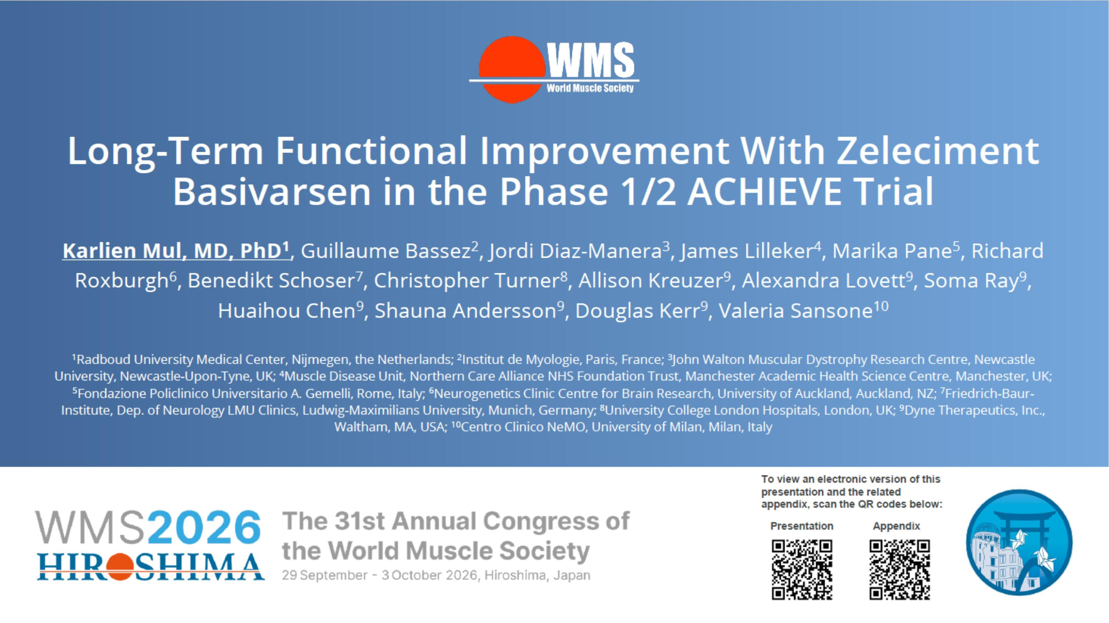

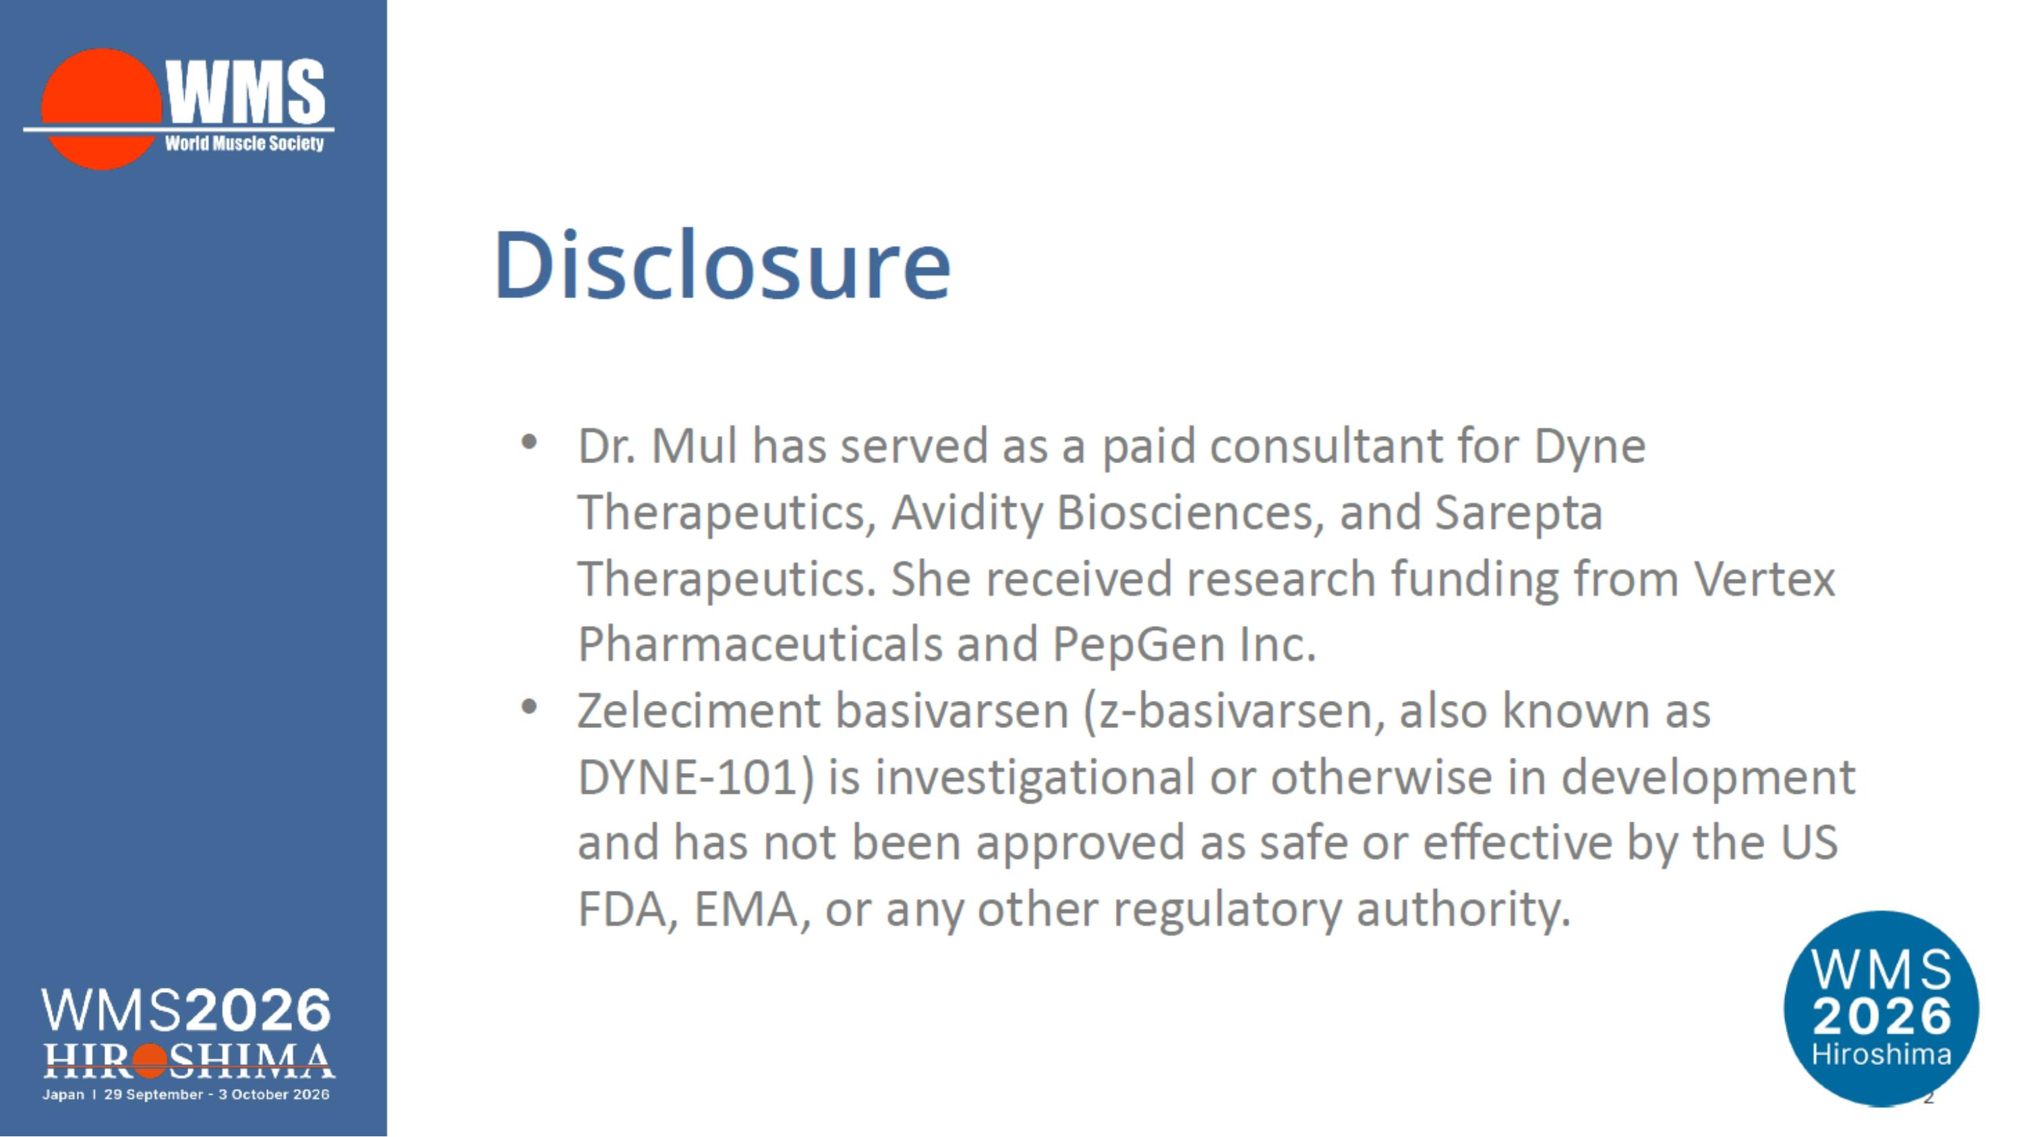

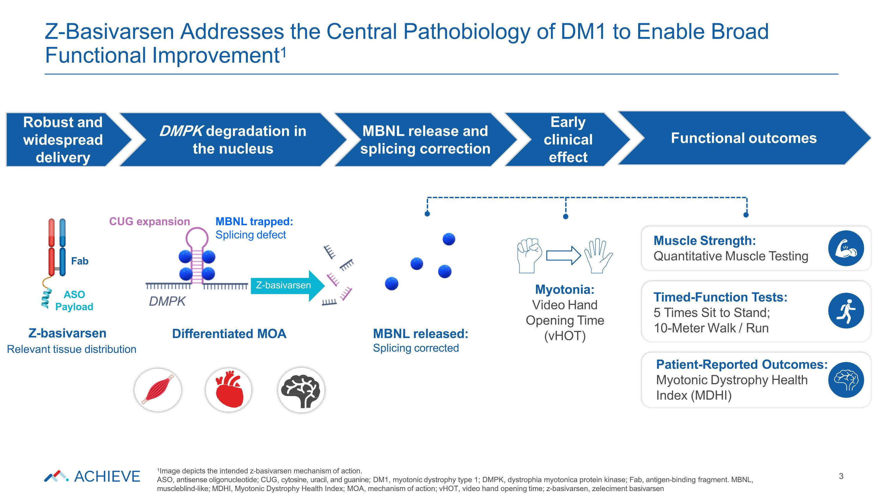
Z-Basivarsen Addresses the Central Pathobiology of DM1 to Enable Broad Functional Improvement1 3 Muscle Strength: Quantitative Muscle Testing Timed-Function Tests: 5 Times Sit to Stand; 10-Meter Walk / Run Patient-Reported Outcomes: Myotonic Dystrophy Health Index (MDHI) Robust and widespread delivery DMPK degradation in the nucleus MBNL release and splicing correction MBNL trapped: Splicing defect CUG expansion MBNL released: Splicing corrected Differentiated MOA Z-basivarsen Relevant tissue distribution Myotonia: Video Hand Opening Time (vHOT) DMPK Early clinical effect Z-basivarsen Functional outcomes 1Image depicts the intended z-basivarsen mechanism of action. ASO, antisense oligonucleotide; CUG, cytosine, uracil, and guanine; DM1, myotonic dystrophy type 1; DMPK, dystrophia myotonica protein kinase; Fab, antigen-binding fragment. MBNL, muscleblind-like; MDHI, Myotonic Dystrophy Health Index; MOA, mechanism of action; vHOT, video hand opening time; z-basivarsen, zeleciment basivarsen ASO Payload Fab

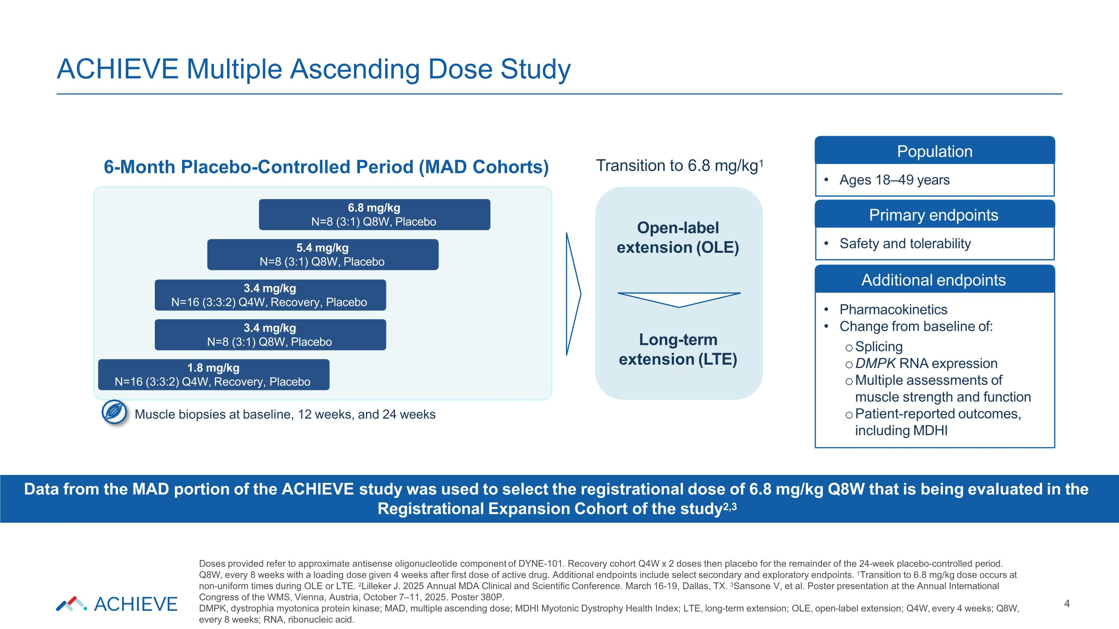
ACHIEVE Multiple Ascending Dose Study 5.4 mg/kg N=8 (3:1) Q8W, Placebo 6.8 mg/kg N=8 (3:1) Q8W, Placebo 3.4 mg/kg N=8 (3:1) Q8W, Placebo 1.8 mg/kg N=16 (3:3:2) Q4W, Recovery, Placebo Open-label extension (OLE) Long-term extension (LTE) Primary endpoints Safety and tolerability Additional endpoints Muscle biopsies at baseline, 12 weeks, and 24 weeks Transition to 6.8 mg/kg1 6-Month Placebo-Controlled Period (MAD Cohorts) Population Ages 18–49 years Pharmacokinetics Change from baseline of: Splicing DMPK RNA expression Multiple assessments of muscle strength and function Patient-reported outcomes, including MDHI Data from the MAD portion of the ACHIEVE study was used to select the registrational dose of 6.8 mg/kg Q8W that is being evaluated in the Registrational Expansion Cohort of the study2,3 Doses provided refer to approximate antisense oligonucleotide component of DYNE-101. Recovery cohort Q4W x 2 doses then placebo for the remainder of the 24-week placebo-controlled period. Q8W, every 8 weeks with a loading dose given 4 weeks after first dose of active drug. Additional endpoints include select secondary and exploratory endpoints. 1Transition to 6.8 mg/kg dose occurs at non-uniform times during OLE or LTE. 2Lilleker J. 2025 Annual MDA Clinical and Scientific Conference. March 16-19, Dallas, TX. 3Sansone V, et al. Poster presentation at the Annual International Congress of the WMS, Vienna, Austria, October 7–11, 2025. Poster 380P. DMPK, dystrophia myotonica protein kinase; MAD, multiple ascending dose; MDHI Myotonic Dystrophy Health Index; LTE, long-term extension; OLE, open-label extension; Q4W, every 4 weeks; Q8W, every 8 weeks; RNA, ribonucleic acid. 3.4 mg/kg N=16 (3:3:2) Q4W, Recovery, Placebo 4

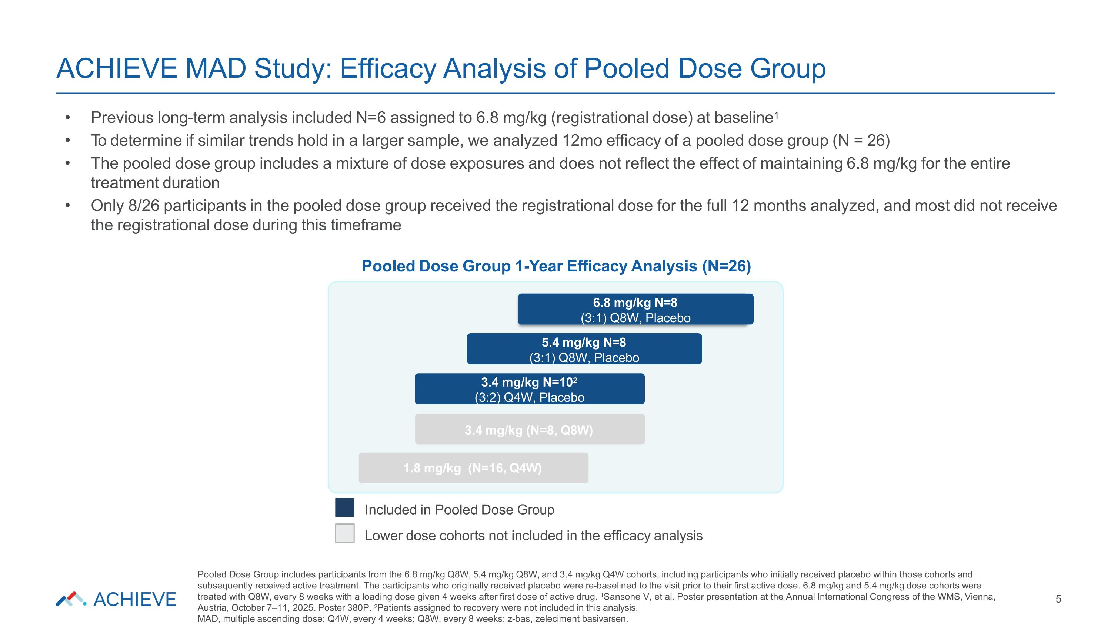
ACHIEVE MAD Study: Efficacy Analysis of Pooled Dose Group 5 1.8 mg/kg (N=16, Q4W) Included in Pooled Dose Group Lower dose cohorts not included in the efficacy analysis 5.4 mg/kg (N=8, Q8W) 6.8 mg/kg (N=8, Q8W) Previous long-term analysis included N=6 assigned to 6.8 mg/kg (registrational dose) at baseline1 To determine if similar trends hold in a larger sample, we analyzed 12mo efficacy of a pooled dose group (N = 26) The pooled dose group includes a mixture of dose exposures and does not reflect the effect of maintaining 6.8 mg/kg for the entire treatment duration Only 8/26 participants in the pooled dose group received the registrational dose for the full 12 months analyzed, and most did not receive the registrational dose during this timeframe Pooled Dose Group 1-Year Efficacy Analysis (N=26) 6.8 mg/kg N=8 (3:1) Q8W, Placebo 5.4 mg/kg N=8 (3:1) Q8W, Placebo 3.4 mg/kg N=102 (3:2) Q4W, Placebo 3.4 mg/kg (N=8, Q8W) Pooled Dose Group includes participants from the 6.8 mg/kg Q8W, 5.4 mg/kg Q8W, and 3.4 mg/kg Q4W cohorts, including participants who initially received placebo within those cohorts and subsequently received active treatment. The participants who originally received placebo were re-baselined to the visit prior to their first active dose. 6.8 mg/kg and 5.4 mg/kg dose cohorts were treated with Q8W, every 8 weeks with a loading dose given 4 weeks after first dose of active drug. 1Sansone V, et al. Poster presentation at the Annual International Congress of the WMS, Vienna, Austria, October 7–11, 2025. Poster 380P. 2Patients assigned to recovery were not included in this analysis. MAD, multiple ascending dose; Q4W, every 4 weeks; Q8W, every 8 weeks; z-bas, zeleciment basivarsen.

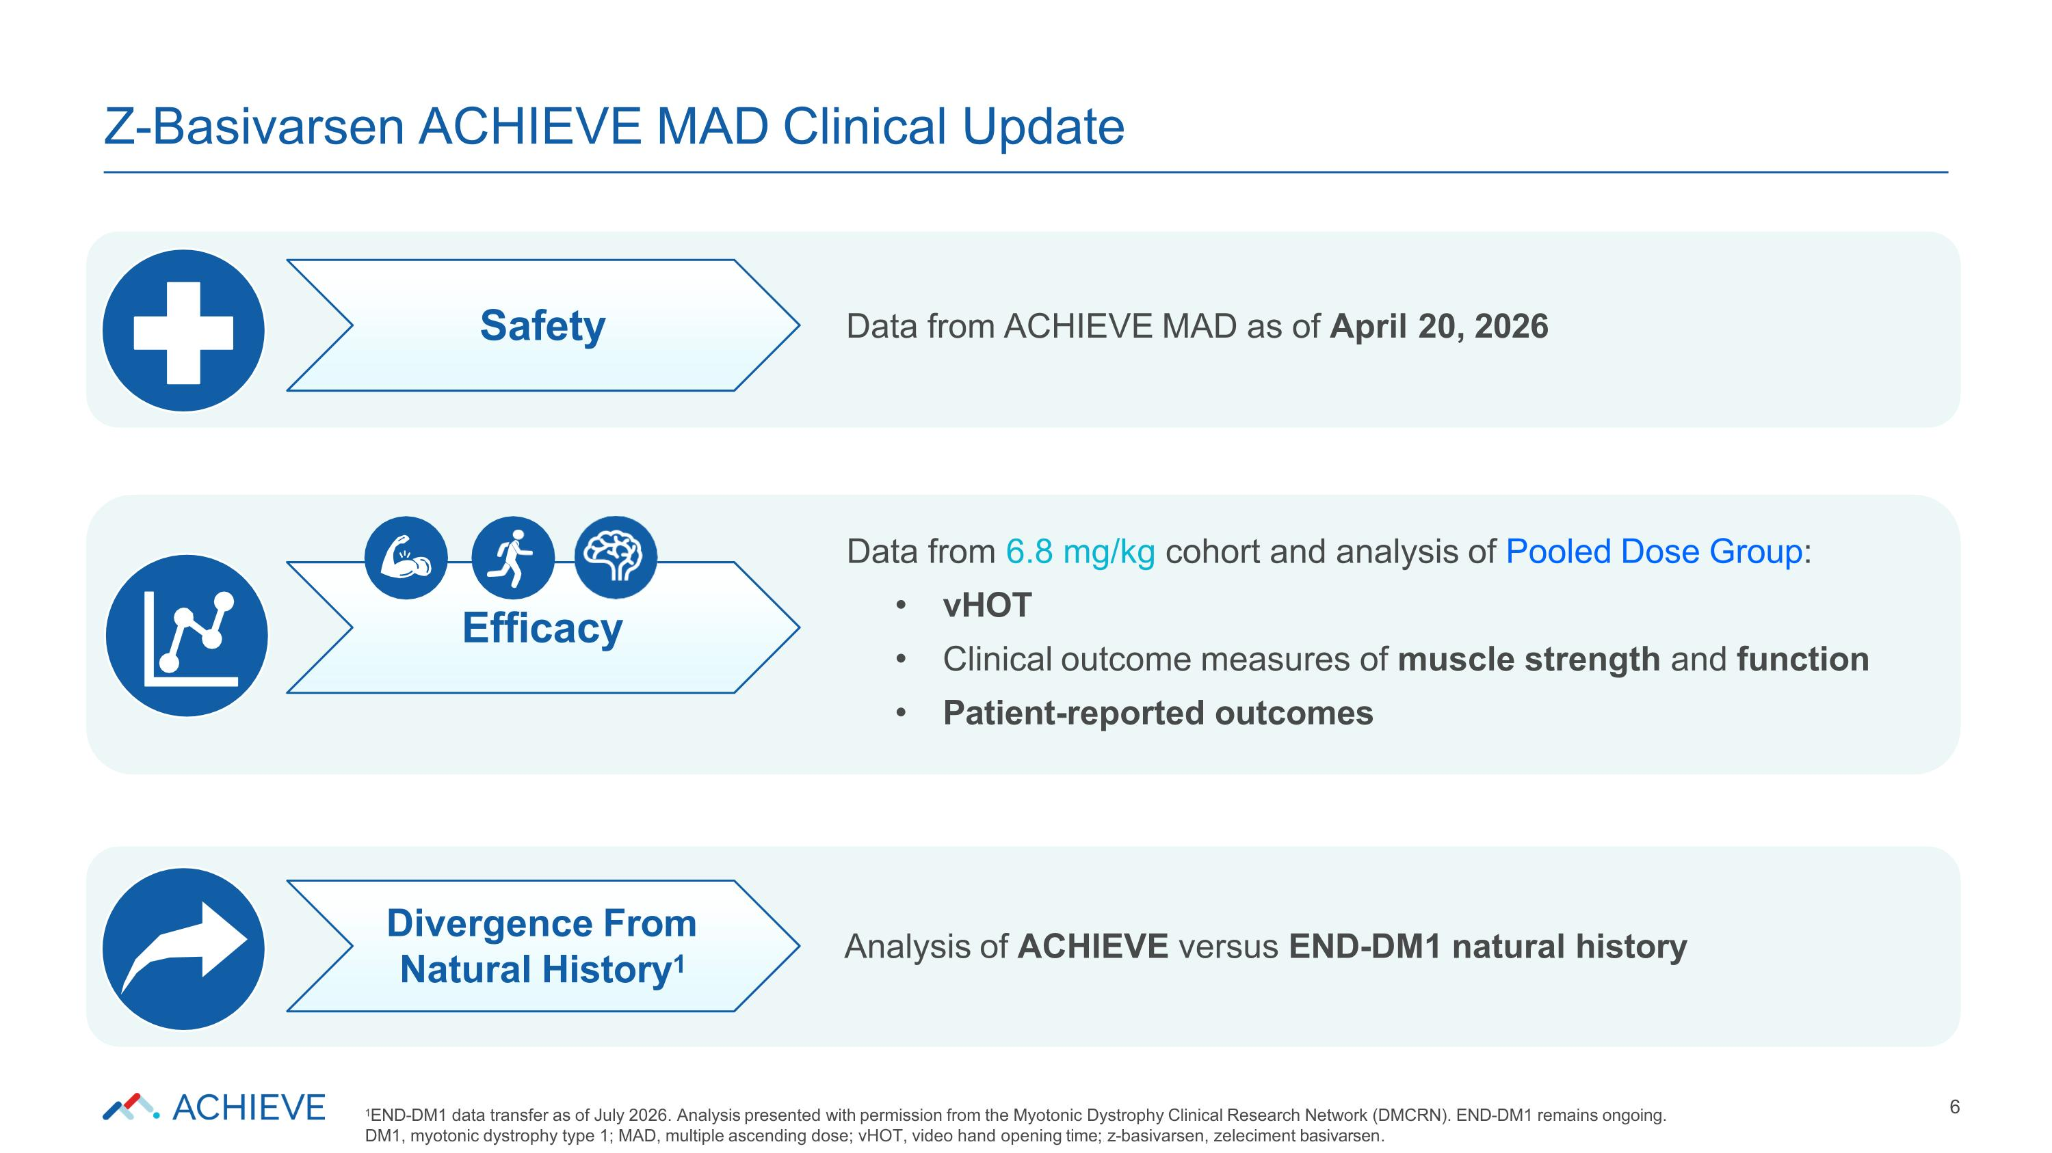
Analysis of ACHIEVE versus END-DM1 natural history Data from 6.8 mg/kg cohort and analysis of Pooled Dose Group: vHOT Clinical outcome measures of muscle strength and function Patient-reported outcomes Data from ACHIEVE MAD as of April 20, 2026 Z-Basivarsen ACHIEVE MAD Clinical Update 6 Safety Efficacy Divergence From Natural History1 1END-DM1 data transfer as of July 2026. Analysis presented with permission from the Myotonic Dystrophy Clinical Research Network (DMCRN). END-DM1 remains ongoing. DM1, myotonic dystrophy type 1; MAD, multiple ascending dose; vHOT, video hand opening time;; z-basivarsen, zeleciment basivarsen..

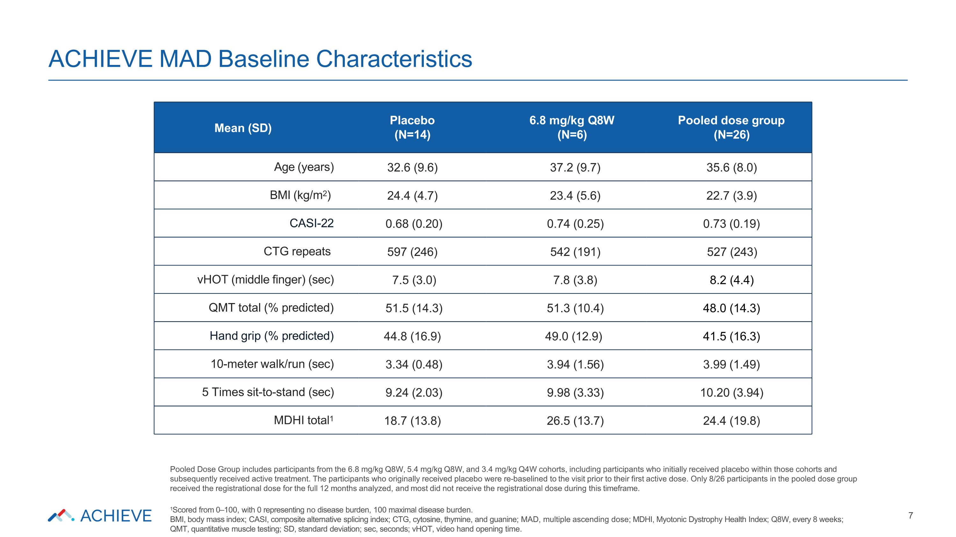
ACHIEVE MAD Baseline Characteristics 7 Mean (SD) Placebo (N=14) 6.8 mg/kg Q8W (N=6) Pooled dose group (N=26) Age (years) 32.6 (9.6) 37.2 (9.7) 35.6 (8.0) BMI (kg/m2) 24.4 (4.7) 23.4 (5.6) 22.7 (3.9) CASI-22 0.68 (0.20) 0.74 (0.25) 0.73 (0.19) CTG repeats 597 (246) 542 (191) 527 (243) vHOT (middle finger) (sec) 7.5 (3.0) 7.8 (3.8) 8.2 (4.4) QMT total (% predicted) 51.5 (14.3) 51.3 (10.4) 48.0 (14.3) Hand grip (% predicted) 44.8 (16.9) 49.0 (12.9) 41.5 (16.3) 10-meter walk/run (sec) 3.34 (0.48) 3.94 (1.56) 3.99 (1.49) 5 Times sit-to-stand (sec) 9.24 (2.03) 9.98 (3.33) 10.20 (3.94) MDHI total1 18.7 (13.8) 26.5 (13.7) 24.4 (19.8) Pooled Dose Group includes participants from the 6.8 mg/kg Q8W, 5.4 mg/kg Q8W, and 3.4 mg/kg Q4W cohorts, including participants who initially received placebo within those cohorts and subsequently received active treatment. The participants who originally received placebo were re-baselined to the visit prior to their first active dose. Only 8/26 participants in the pooled dose group received the registrational dose for the full 12 months analyzed, and most did not receive the registrational dose during this timeframe. 1Scored from 0–100, with 0 representing no disease burden, 100 maximal disease burden. BMI, body mass index; CASI, composite alternative splicing index; CTG, cytosine, thymine, and guanine; MAD, multiple ascending dose; MDHI, Myotonic Dystrophy Health Index; Q8W, every 8 weeks; QMT, quantitative muscle testing; SD, standard deviation; sec, seconds; vHOT, video hand opening time.

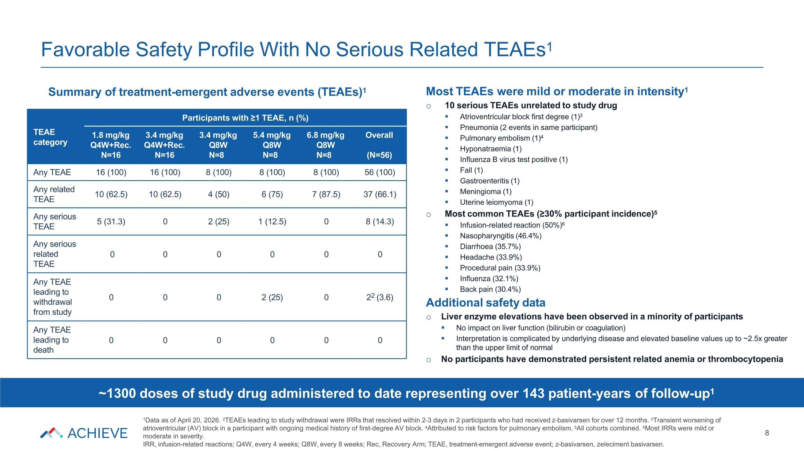
Favorable Safety Profile With No Serious Related TEAEs1 Summary of treatment-emergent adverse events (TEAEs)1 TEAE category Participants with ≥1 TEAE, n (%) 1.8 mg/kg Q4W+Rec. N=16 3.4 mg/kg Q4W+Rec. N=16 3.4 mg/kg Q8W N=8 5.4 mg/kg Q8W N=8 6.8 mg/kg Q8W N=8 Overall (N=56) Any TEAE 16 (100) 16 (100) 8 (100) 8 (100) 8 (100) 56 (100) Any related TEAE 10 (62.5) 10 (62.5) 4 (50) 6 (75) 7 (87.5) 37 (66.1) Any serious TEAE 5 (31.3) 0 2 (25) 1 (12.5) 0 8 (14.3) Any serious related TEAE 0 0 0 0 0 0 Any TEAE leading to withdrawal from study 0 0 0 2 (25) 0 22 (3.6) Any TEAE leading to death 0 0 0 0 0 0 Most TEAEs were mild or moderate in intensity1 10 serious TEAEs unrelated to study drug Atrioventricular block first degree (1)3 Pneumonia (2 events in same participant) Pulmonary embolism (1)4 Hyponatraemia (1) Influenza B virus test positive (1) Fall (1) Gastroenteritis (1) Meningioma (1) Uterine leiomyoma (1) Most common TEAEs (≥30% participant incidence)5 Infusion-related reaction (50%)6 Nasopharyngitis (46.4%) Diarrhoea (35.7%) Headache (33.9%) Procedural pain (33.9%) Influenza (32.1%) Back pain (30.4%) Additional safety data Liver enzyme elevations have been observed in a minority of participants No impact on liver function (bilirubin or coagulation) Interpretation is complicated by underlying disease and elevated baseline values up to ~2.5x greater than the upper limit of normal No participants have demonstrated persistent related anemia or thrombocytopenia ~1300 doses of study drug administered to date representing over 143 patient-years of follow-up1 1Data as of April 20, 2026. 2TEAEs leading to study withdrawal were IRRs that resolved within 2-3 days in 2 participants who had received z-basivarsen for over 12 months. 3Transient worsening of atrioventricular (AV) block in a participant with ongoing medical history of first-degree AV block. 4Attributed to risk factors for pulmonary embolism. 5All cohorts combined. 6Most IRRs were mild or moderate in severity. IRR, infusion-related reactions; Q4W, every 4 weeks; Q8W, every 8 weeks; Rec, Recovery Arm; TEAE, treatment-emergent adverse event; z-basivarsen, zeleciment basivarsen. 8

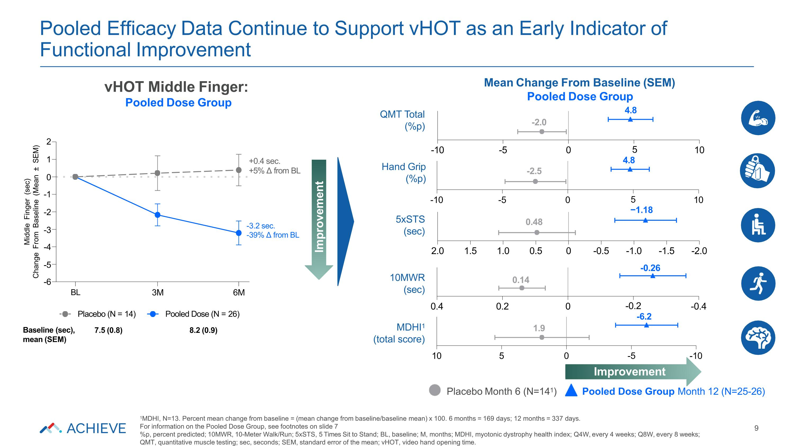
-10 -5 0 10 9 Placebo Month 6 (N=141) Pooled Dose Group Month 12 (N=25-26) 5xSTS (sec) 0.48 5 −1.18 QMT Total (%p) -2.0 4.8 Improvement Mean Change From Baseline (SEM) Pooled Dose Group vHOT Middle Finger: Pooled Dose Group MDHI1 (total score) 1.9 10MWR (sec) -0.26 0.14 Hand Grip (%p) -2.5 Pooled Efficacy Data Continue to Support vHOT as an Early Indicator of Functional Improvement 1MDHI, N=13. Percent mean change from baseline = (mean change from baseline/baseline mean) x 100. 6 months = 169 days; 12 months = 337 days. For information on the Pooled Dose Group, see footnotes on slide 7 %p, percent predicted; 10MWR, 10-Meter Walk/Run; 5xSTS, 5 Times Sit to Stand; BL, baseline; M, months; MDHI, myotonic dystrophy health index; Q4W, every 4 weeks; Q8W, every 8 weeks; QMT, quantitative muscle testing; sec, seconds; SEM, standard error of the mean; vHOT, video hand opening time. 2 1 0 -1 -2 -3 -4 -5 -6 Middle Finger (sec) Change From Baseline (Mean ± SEM) BL 3M 6M Placebo (N = 14) 7.5 (0.8) Pooled Dose (N = 26) 8.2 (0.9) +0.4 sec. +5% Δ from BL Baseline (sec), mean (SEM) -3.2 sec. -39% Δ from BL -10 -5 0 5 4.8 10 -2.0 -1.5 -1.0 -0.5 0.5 1.0 1.5 2.0 0 -0.4 -0.2 -6.2 0.2 0.4 0 -10 -5 Improvement 0 5 10

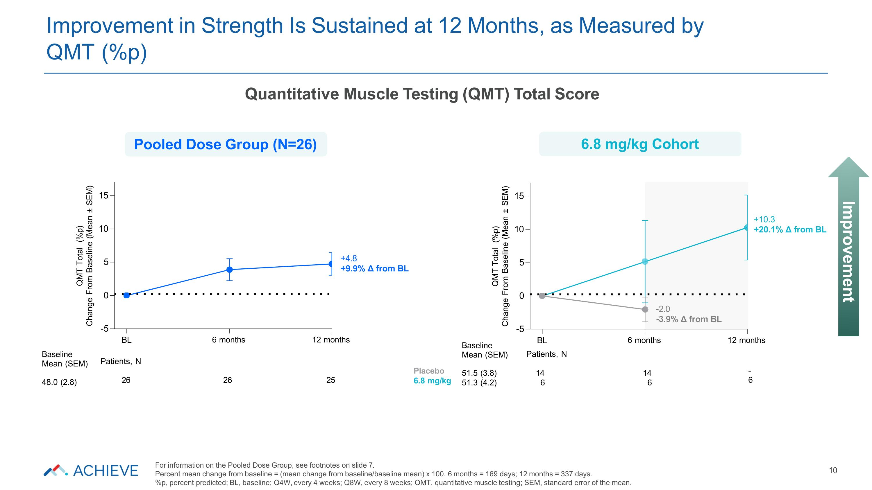
QMT Total (%p) Change From Baseline (Mean ± SEM) 6 months 12 months 0 5 10 15 -5 +10.3 +20.1% Δ from BL -2.0 -3.9% Δ from BL BL Patients, N Placebo 6.8 mg/kg 14 6 14 6 - 6 Baseline Mean (SEM) 51.5 (3.8) 51.3 (4.2) QMT Total (%p) Change From Baseline (Mean ± SEM) BL 6 months 12 months 0 5 10 15 -5 +4.8 +9.9% Δ from BL Baseline Mean (SEM) 48.0 (2.8) Patients, N 26 26 25 Improvement in Strength Is Sustained at 12 Months, as Measured by QMT (%p) 10 Pooled Dose Group (N=26) 6.8 mg/kg Cohort Quantitative Muscle Testing (QMT) Total Score Improvement For information on the Pooled Dose Group, see footnotes on slide 7. Percent mean change from baseline = (mean change from baseline/baseline mean) x 100. 6 months = 169 days; 12 months = 337 days. %p, percent predicted; BL, baseline; Q4W, every 4 weeks; Q8W, every 8 weeks; QMT, quantitative muscle testing; SEM, standard error of the mean.

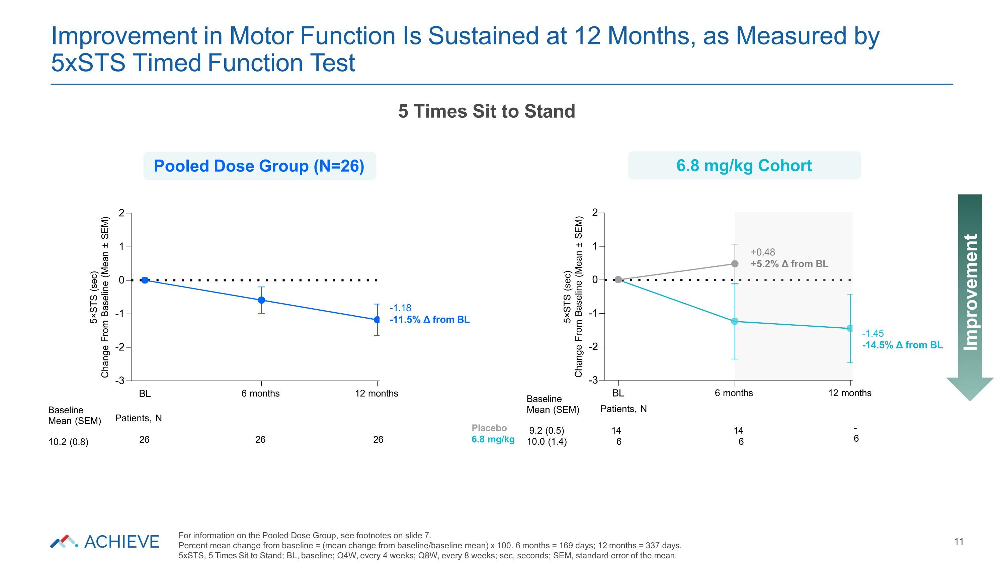
-3 -2 -1 0 1 2 5×STS (sec) Change From Baseline (Mean ± SEM) 6 months 12 months -1.45 -14.5% Δ from BL +0.48 +5.2% Δ from BL BL Patients, N Placebo 6.8 mg/kg 14 6 14 6 - 6 Baseline Mean (SEM) 9.2 (0.5) 10.0 (1.4) -3 -2 -1 0 1 2 5×STS (sec) Change From Baseline (Mean ± SEM) BL 6 months 12 months -1.18 -11.5% Δ from BL Baseline Mean (SEM) 10.2 (0.8) Patients, N 26 26 26 Improvement in Motor Function Is Sustained at 12 Months, as Measured by 5xSTS Timed Function Test 11 Improvement 5 Times Sit to Stand Pooled Dose Group (N=26) 6.8 mg/kg Cohort For information on the Pooled Dose Group, see footnotes on slide 7. Percent mean change from baseline = (mean change from baseline/baseline mean) x 100. 6 months = 169 days; 12 months = 337 days. 5xSTS, 5 Times Sit to Stand; BL, baseline; Q4W, every 4 weeks; Q8W, every 8 weeks; sec, seconds; SEM, standard error of the mean.

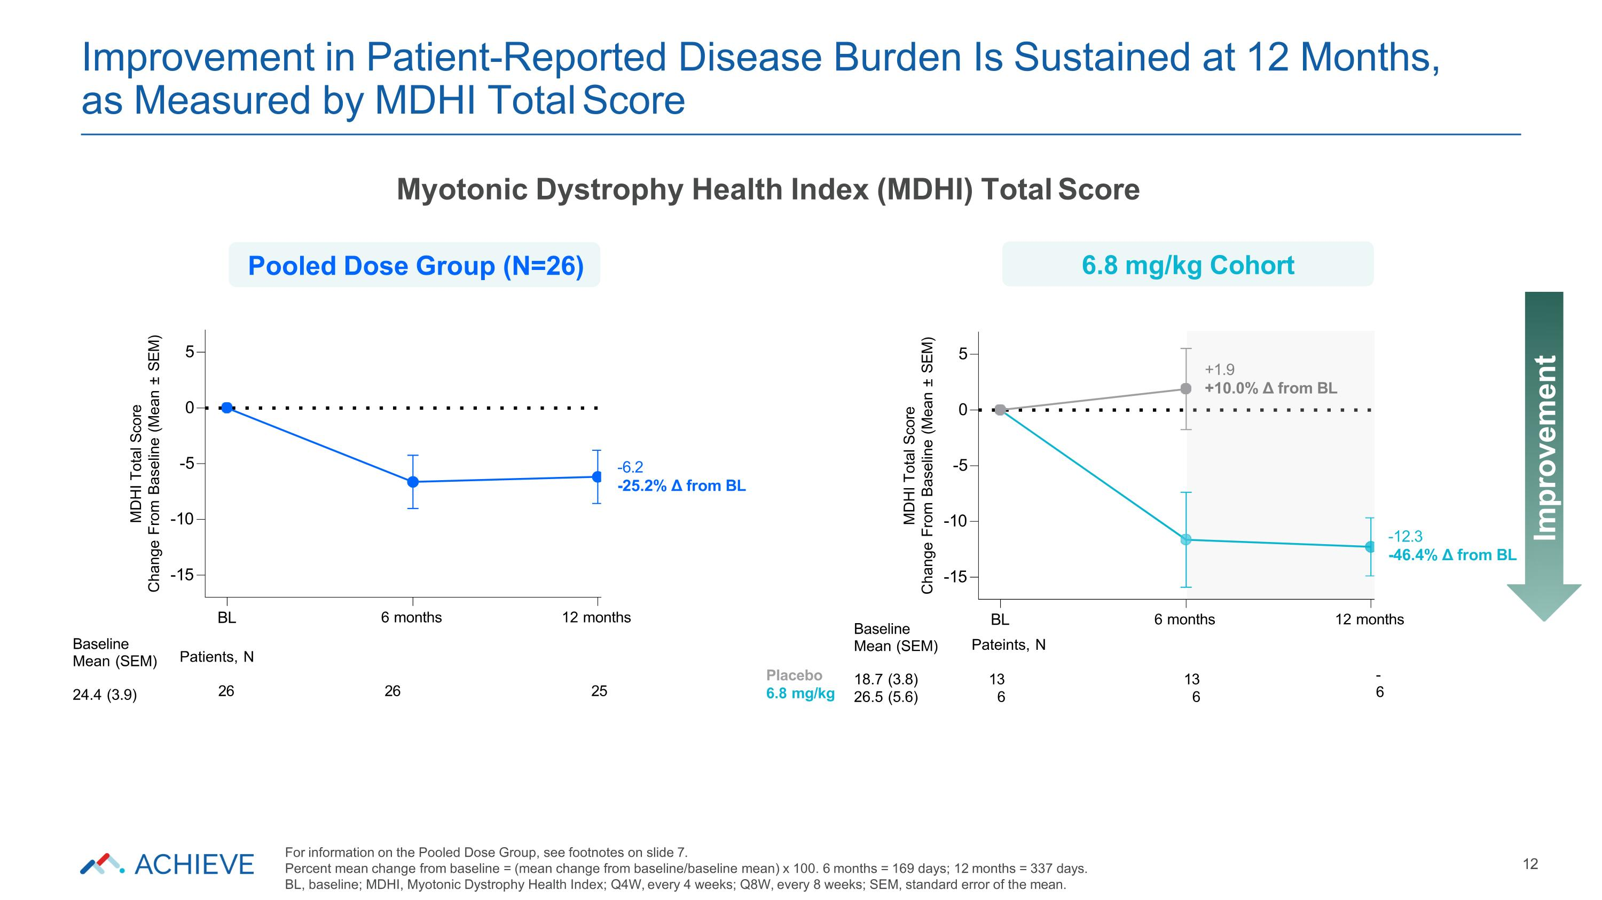
-15 -10 -5 0 5 MDHI Total Score Change From Baseline (Mean ± SEM) 6 months 12 months +1.9 +10.0% Δ from BL BL Pateints, N -12.3 -46.4% Δ from BL Placebo 6.8 mg/kg 13 6 13 6 - 6 Baseline Mean (SEM) 18.7 (3.8) 26.5 (5.6) -15 -10 -5 0 5 MDHI Total Score Change From Baseline (Mean ± SEM) BL 6 months 12 months -6.2 -25.2% Δ from BL Baseline Mean (SEM) 24.4 (3.9) Patients, N 26 26 25 Improvement in Patient-Reported Disease Burden Is Sustained at 12 Months, as Measured by MDHI Total Score 12 Improvement Myotonic Dystrophy Health Index (MDHI) Total Score Pooled Dose Group (N=26) 6.8 mg/kg Cohort For information on the Pooled Dose Group, see footnotes on slide 7. Percent mean change from baseline = (mean change from baseline/baseline mean) x 100. 6 months = 169 days; 12 months = 337 days. BL, baseline; MDHI, Myotonic Dystrophy Health Index; Q4W, every 4 weeks; Q8W, every 8 weeks; SEM, standard error of the mean.

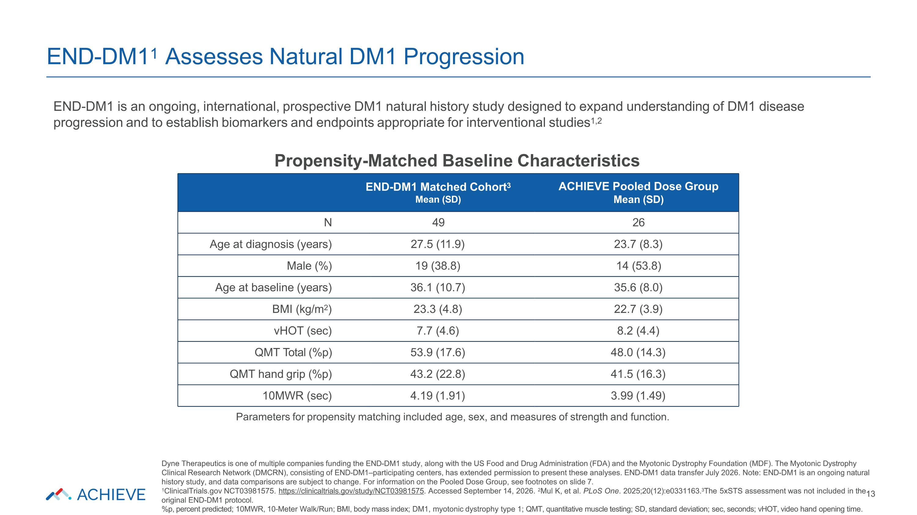
END-DM11 Assesses Natural DM1 Progression Dyne Therapeutics is one of multiple companies funding the END-DM1 study, along with the US Food and Drug Administration (FDA) and the Myotonic Dystrophy Foundation (MDF). The Myotonic Dystrophy Clinical Research Network (DMCRN), consisting of END-DM1–participating centers, has extended permission to present these analyses. END-DM1 data transfer July 2026. Note: END-DM1 is an ongoing natural history study, and data comparisons are subject to change. For information on the Pooled Dose Group, see footnotes on slide 7. 1ClinicalTrials.gov NCT03981575. https://clinicaltrials.gov/study/NCT03981575. Accessed September 14, 2026. 2Mul K, et al. PLoS One. 2025;20(12):e0331163.3The 5xSTS assessment was not included in the13 original END-DM1 protocol. %p, percent predicted; 10MWR, 10-Meter Walk/Run; BMI, body mass index; DM1, myotonic dystrophy type 1; QMT, quantitative muscle testing; SD, standard deviation; sec, seconds; vHOT, video hand opening time. END-DM1 Matched Cohort3 Mean (SD) ACHIEVE Pooled Dose Group Mean (SD) N 49 26 Age at diagnosis (years) 27.5 (11.9) 23.7 (8.3) Male (%) 19 (38.8) 14 (53.8) Age at baseline (years) 36.1 (10.7) 35.6 (8.0) BMI (kg/m2) 23.3 (4.8) 22.7 (3.9) vHOT (sec) 7.7 (4.6) 8.2 (4.4) QMT Total (%p) 53.9 (17.6) 48.0 (14.3) QMT hand grip (%p) 43.2 (22.8) 41.5 (16.3) 10MWR (sec) 4.19 (1.91) 3.99 (1.49) END-DM1 is an ongoing, international, prospective DM1 natural history study designed to expand understanding of DM1 disease progression and to establish biomarkers and endpoints appropriate for interventional studies1,2 Propensity-Matched Baseline Characteristics Parameters for propensity matching included age, sex, and measures of strength and function.

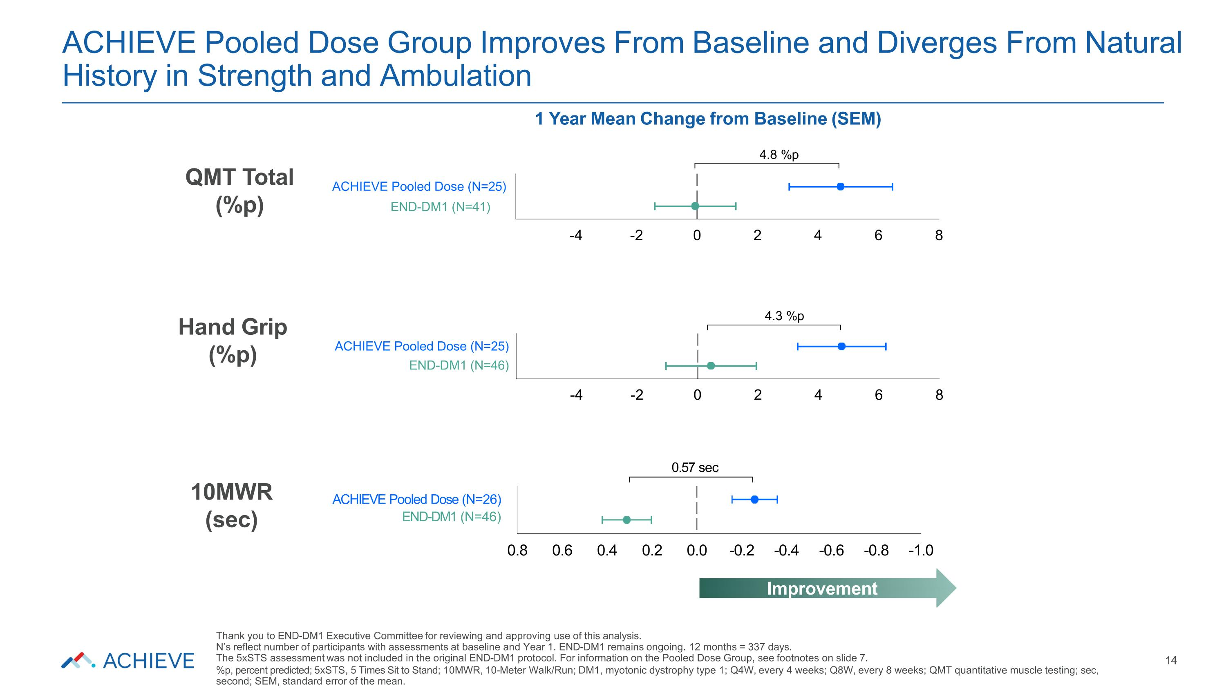
ACHIEVE Pooled Dose (N=26) END-DM1 (N=46) 0.57 sec -4 -2 0 2 4 6 8 4.3 %p ACHIEVE Pooled Dose (N=25) END-DM1 (N=46) -4 -2 0 2 4 6 8 1 Year Mean Change from Baseline (SEM) 4.8 %p ACHIEVE Pooled Dose (N=25) END-DM1 (N=41) ACHIEVE Pooled Dose Group Improves From Baseline and Diverges From Natural History in Strength and Ambulation 14 QMT Total (%p) Hand Grip (%p) 10MWR (sec) 0.8 0.6 0.4 0.2 0.0 -0.2 -0.4 -0.6 -0.8 -1.0 Improvement Thank you to END-DM1 Executive Committee for reviewing and approving use of this analysis. N’s reflect number of participants with assessments at baseline and Year 1. END-DM1 remains ongoing. 12 months = 337 days. The 5xSTS assessment was not included in the original END-DM1 protocol. For information on the Pooled Dose Group, see footnotes on slide 7. %p, percent predicted; 5xSTS, 5 Times Sit to Stand; 10MWR, 10-Meter Walk/Run; DM1, myotonic dystrophy type 1; Q4W, every 4 weeks; Q8W, every 8 weeks; QMT quantitative muscle testing; sec, second; SEM, standard error of the mean.

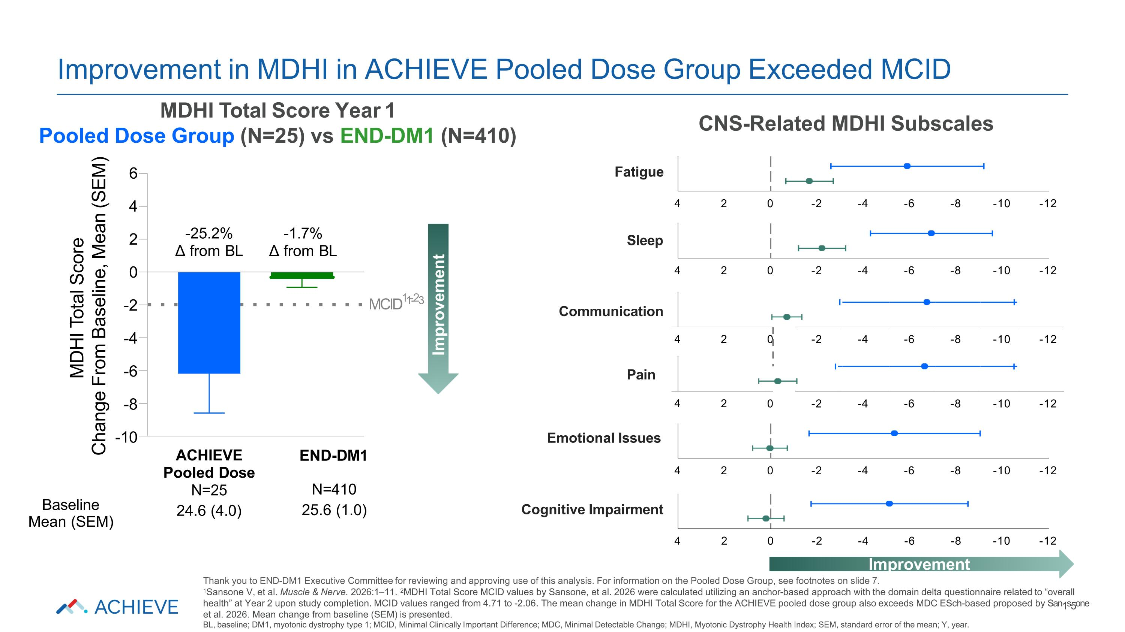
4 2 0 -2 -4 -6 -8 -10 -12 -12 -10 -8 -6 -4 -2 0 2 4 -12 -10 -8 -6 -4 -2 0 -12 -10 -8 -6 -4 -2 0 -12 -10 -8 -6 -4 -2 0 4 2 4 2 4 2 -12 -10 -8 -6 -4 -2 0 2 4 6 4 2 0 -2 -4 -6 -8 -10 -25.2% Δ from BL ACHIEVE Pooled Dose N=25 24.6 (4.0) MDHI Total Score Change From Baseline, Mean (SEM) END-DM1 N=410 25.6 (1.0) -1.7% Δ from BL Baseline Mean (SEM) Improvement in MDHI in ACHIEVE Pooled Dose Group Exceeded MCID MDHI Total Score Year 1 Pooled Dose Group (N=25) vs END-DM1 (N=410) Improvement Fatigue Communication Emotional Issues Sleep Pain Cognitive Impairment Improvement Thank you to END-DM1 Executive Committee for reviewing and approving use of this analysis. For information on the Pooled Dose Group, see footnotes on slide 7. 1Sansone V, et al. Muscle & Nerve. 2026:1–11. 2MDHI Total Score MCID values by Sansone, et al. 2026 were calculated utilizing an anchor-based approach with the domain delta questionnaire related to “overall health” at Year 2 upon study completion. MCID values ranged from 4.71 to -2.06. The mean change in MDHI Total Score for the ACHIEVE pooled dose group also exceeds MDC ESch-based proposed by San1s5one et al. 2026. Mean change from baseline (SEM) is presented. BL, baseline; DM1, myotonic dystrophy type 1; MCID, Minimal Clinically Important Difference; MDC, Minimal Detectable Change; MDHI, Myotonic Dystrophy Health Index; SEM, standard error of the mean; Y, year. CNS-Related MDHI Subscales MCID11--23

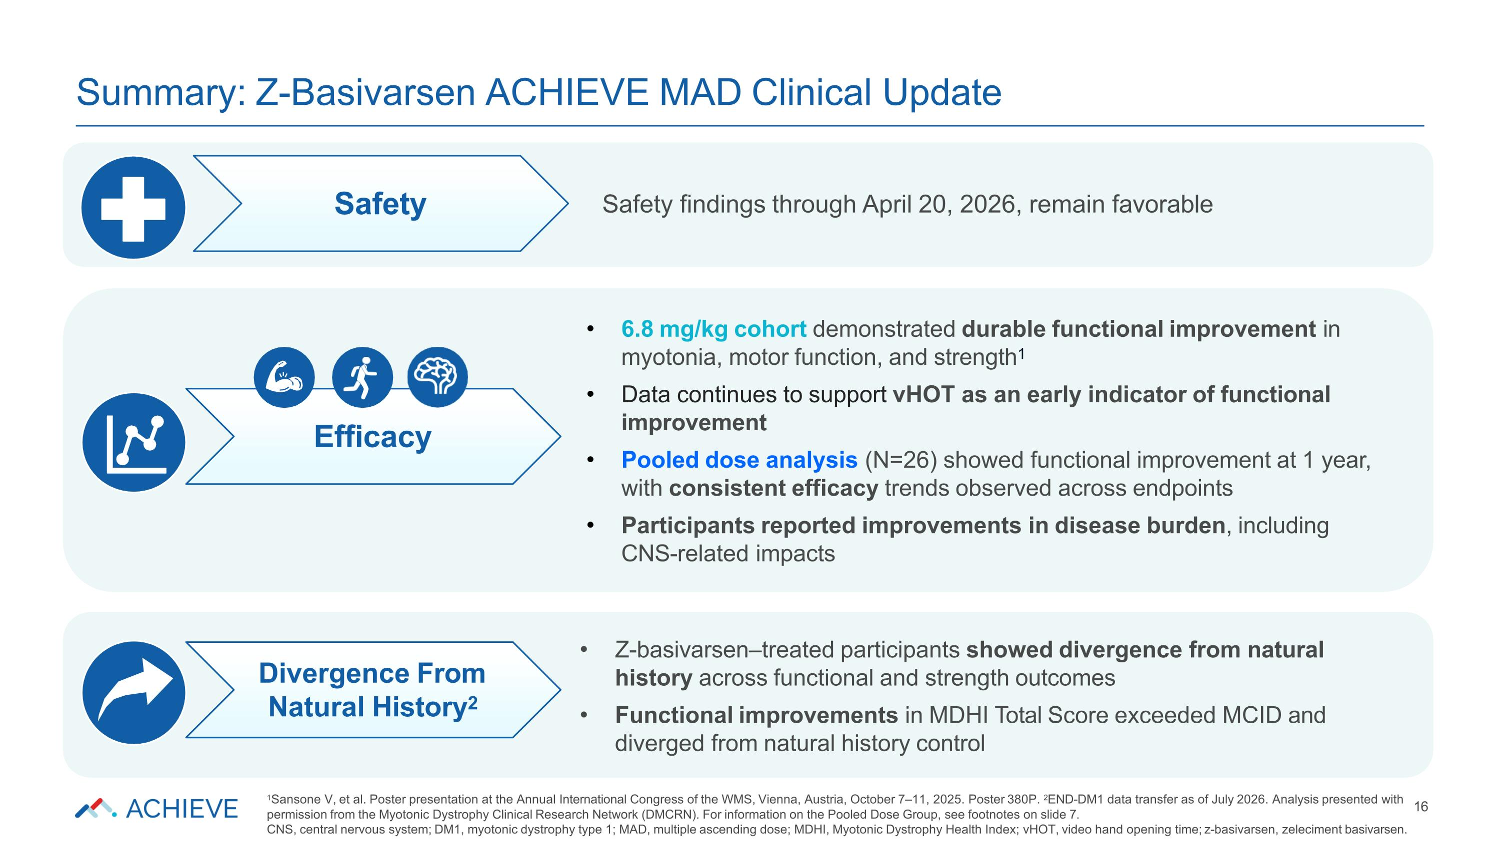
Z-basivarsen–treated participants showed divergence from natural history across functional and strength outcomes Functional improvements in MDHI Total Score exceeded MCID and diverged from natural history control 6.8 mg/kg cohort demonstrated durable functional improvement in myotonia, motor function, and strength1 Data continues to support vHOT as an early indicator of functional improvement Pooled dose analysis (N=26) showed functional improvement at 1 year, with consistent efficacy trends observed across endpoints Participants reported improvements in disease burden, including CNS-related impacts Safety findings through April 20, 2026, remain favorable Summary: Z-Basivarsen ACHIEVE MAD Clinical Update 1Sansone V, et al. Poster presentation at the Annual International Congress of the WMS, Vienna, Austria, October 7–11, 2025. Poster 380P. 2END-DM1 data transfer as of July 2026. Analysis presented with 16 permission from the Myotonic Dystrophy Clinical Research Network (DMCRN). For information on the Pooled Dose Group, see footnotes on slide 7. CNS, central nervous system; DM1, myotonic dystrophy type 1; MAD, multiple ascending dose; MDHI, Myotonic Dystrophy Health Index; vHOT, video hand opening time; z-basivarsen, zeleciment basivarsen. Safety Efficacy Divergence From Natural History2

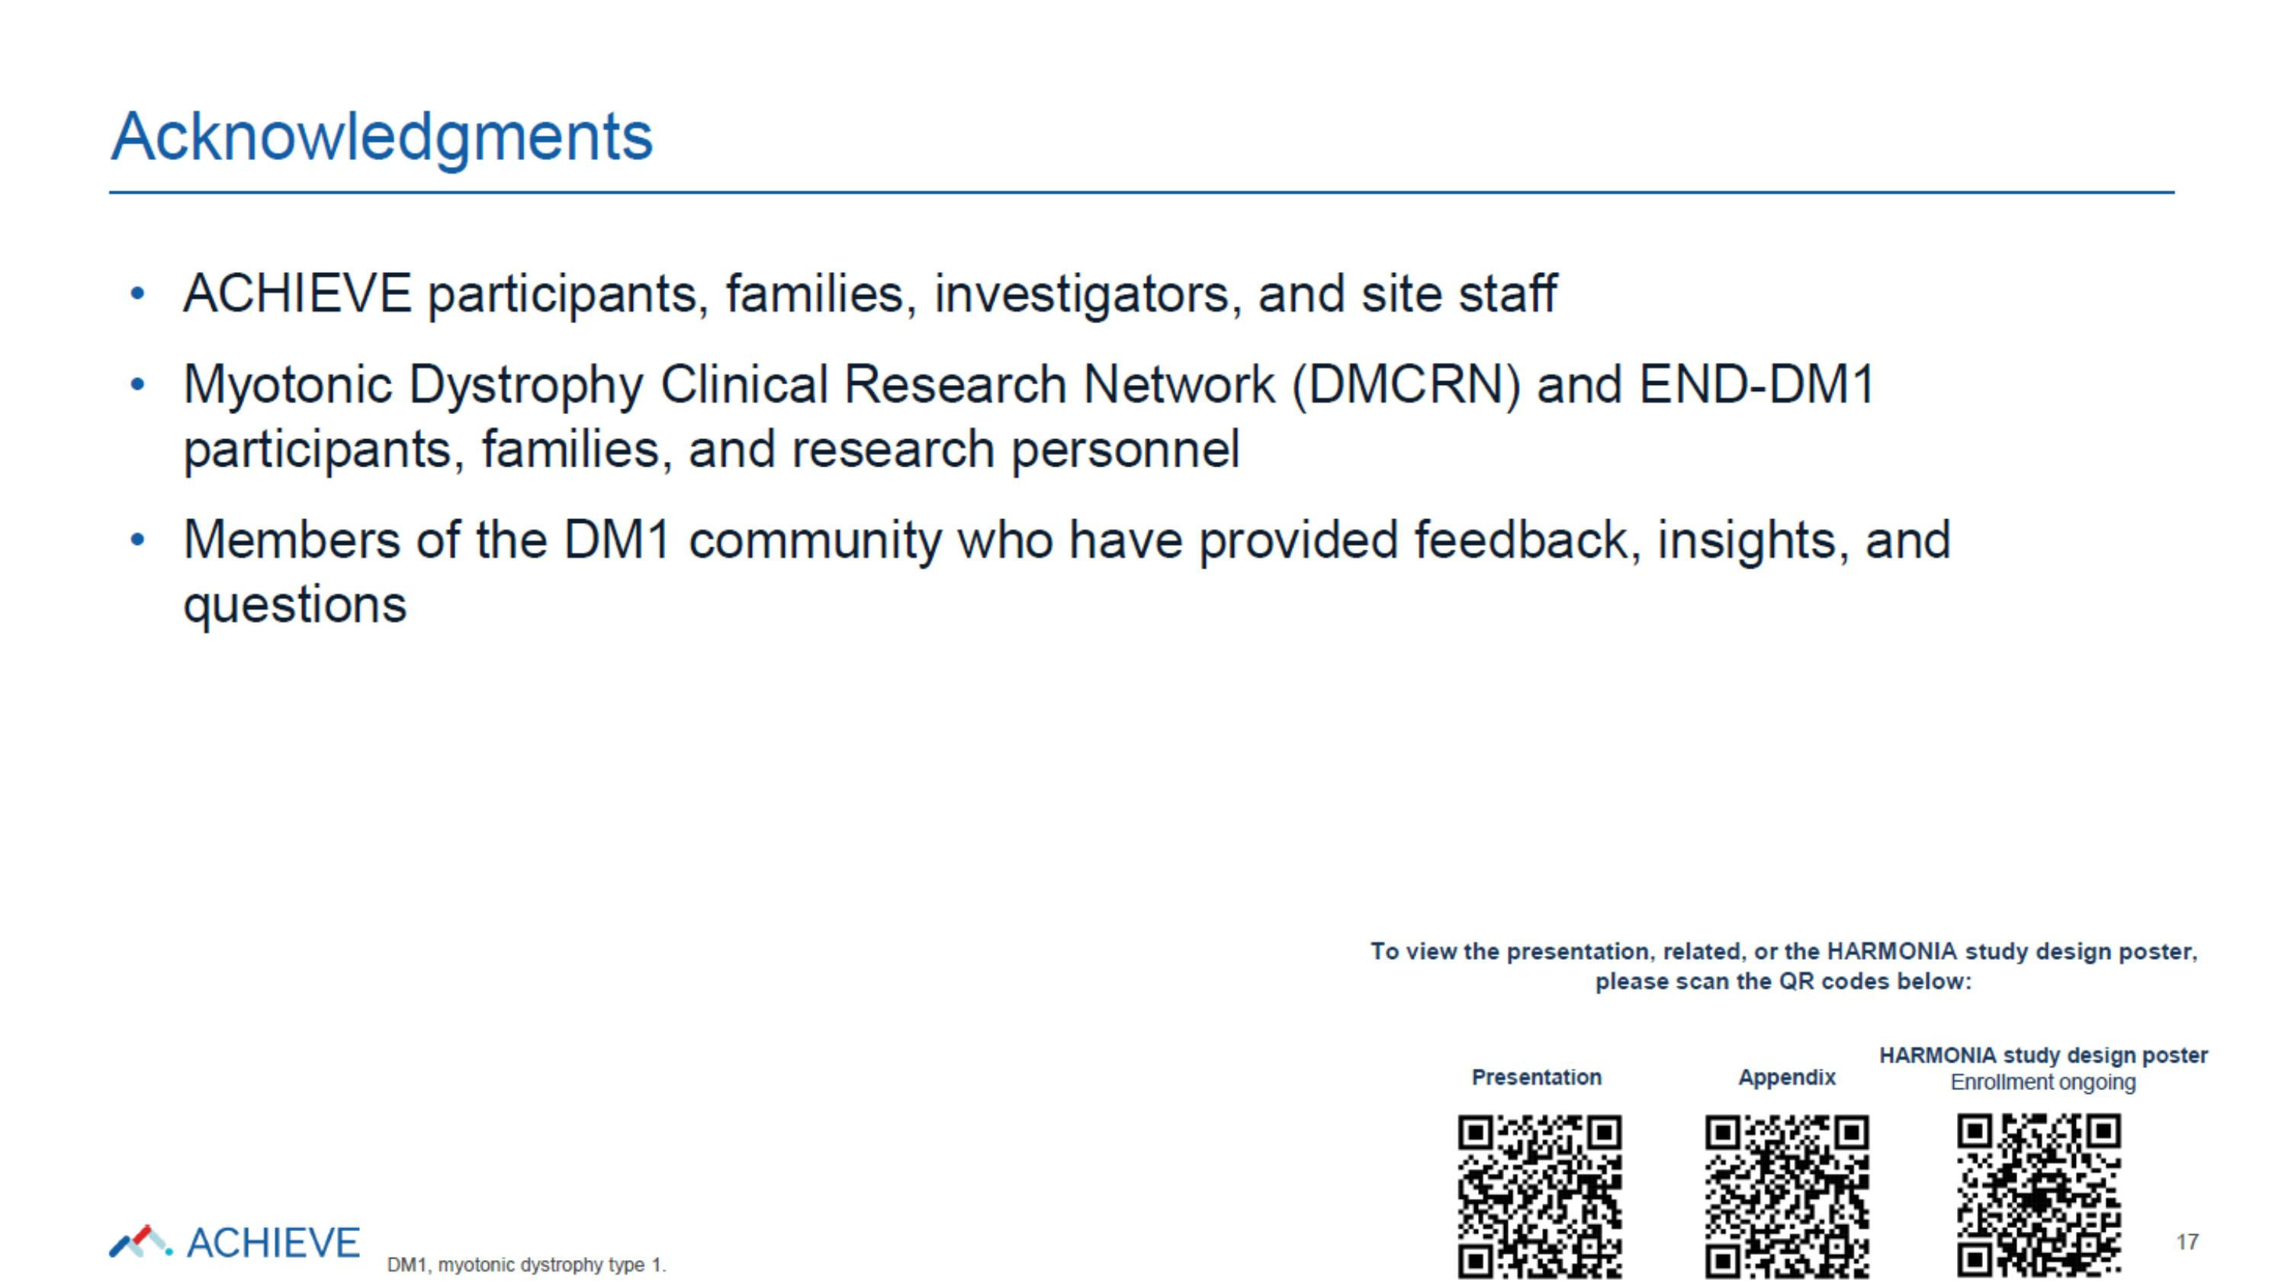

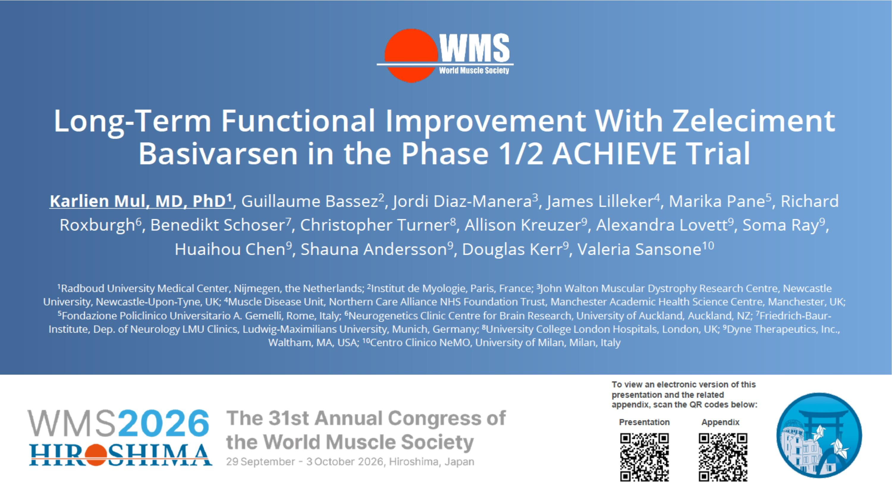

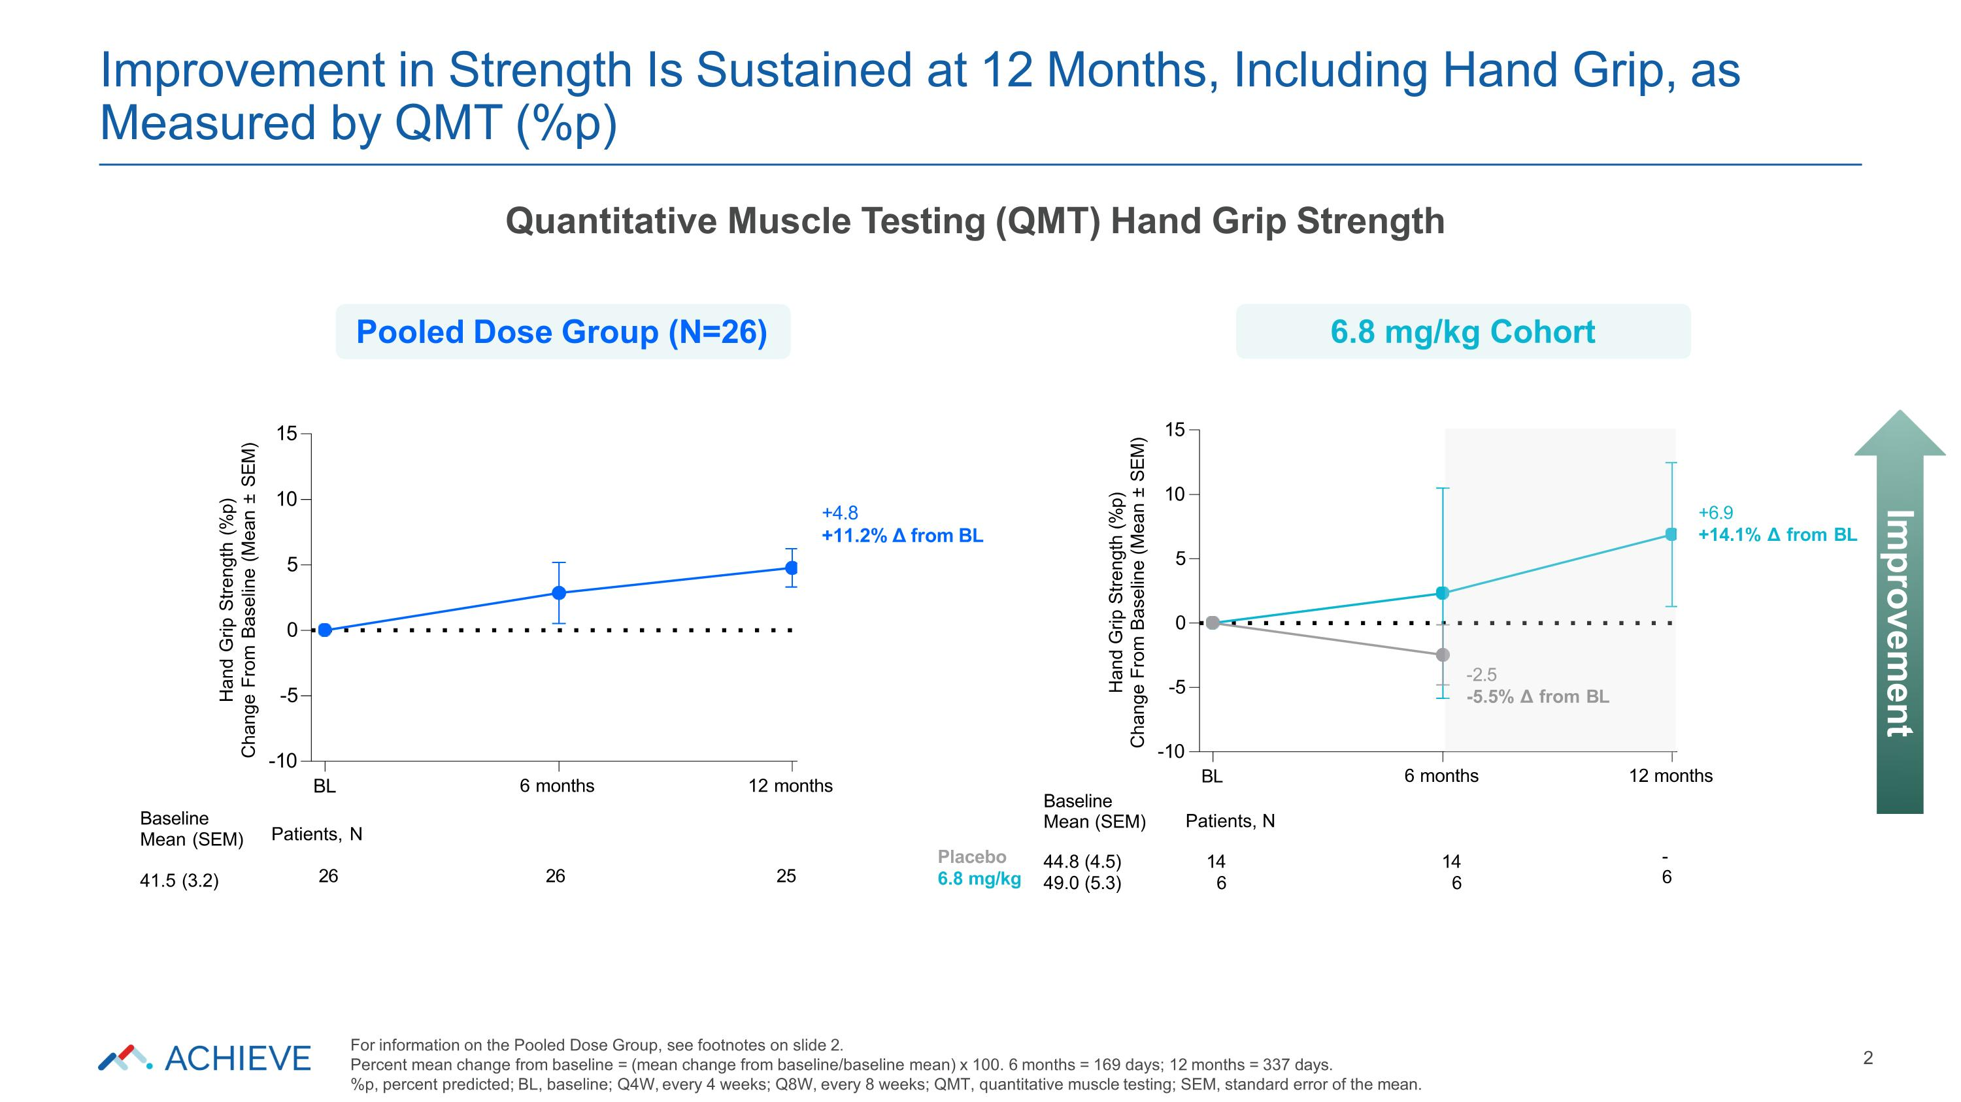
-10 -5 0 5 10 15 Hand Grip Strength (%p) Change From Baseline (Mean ± SEM) BL 6 months 12 months -2.5 -5.5% Δ from BL +6.9 +14.1% Δ from BL Placebo 6.8 mg/kg Patients, N 14 6 14 6 - 6 Baseline Mean (SEM) 44.8 (4.5) 49.0 (5.3) -10 -5 0 5 10 15 Hand Grip Strength (%p) Change From Baseline (Mean ± SEM) BL 6 months 12 months +4.8 +11.2% Δ from BL Baseline Mean (SEM) 41.5 (3.2) Patients, N 26 26 25 Improvement in Strength Is Sustained at 12 Months, Including Hand Grip, as Measured by QMT (%p) 2 Improvement Quantitative Muscle Testing (QMT) Hand Grip Strength Pooled Dose Group (N=26) 6.8 mg/kg Cohort For information on the Pooled Dose Group, see footnotes on slide 2. Percent mean change from baseline = (mean change from baseline/baseline mean) x 100. 6 months = 169 days; 12 months = 337 days. %p, percent predicted; BL, baseline; Q4W, every 4 weeks; Q8W, every 8 weeks; QMT, quantitative muscle testing; SEM, standard error of the mean.

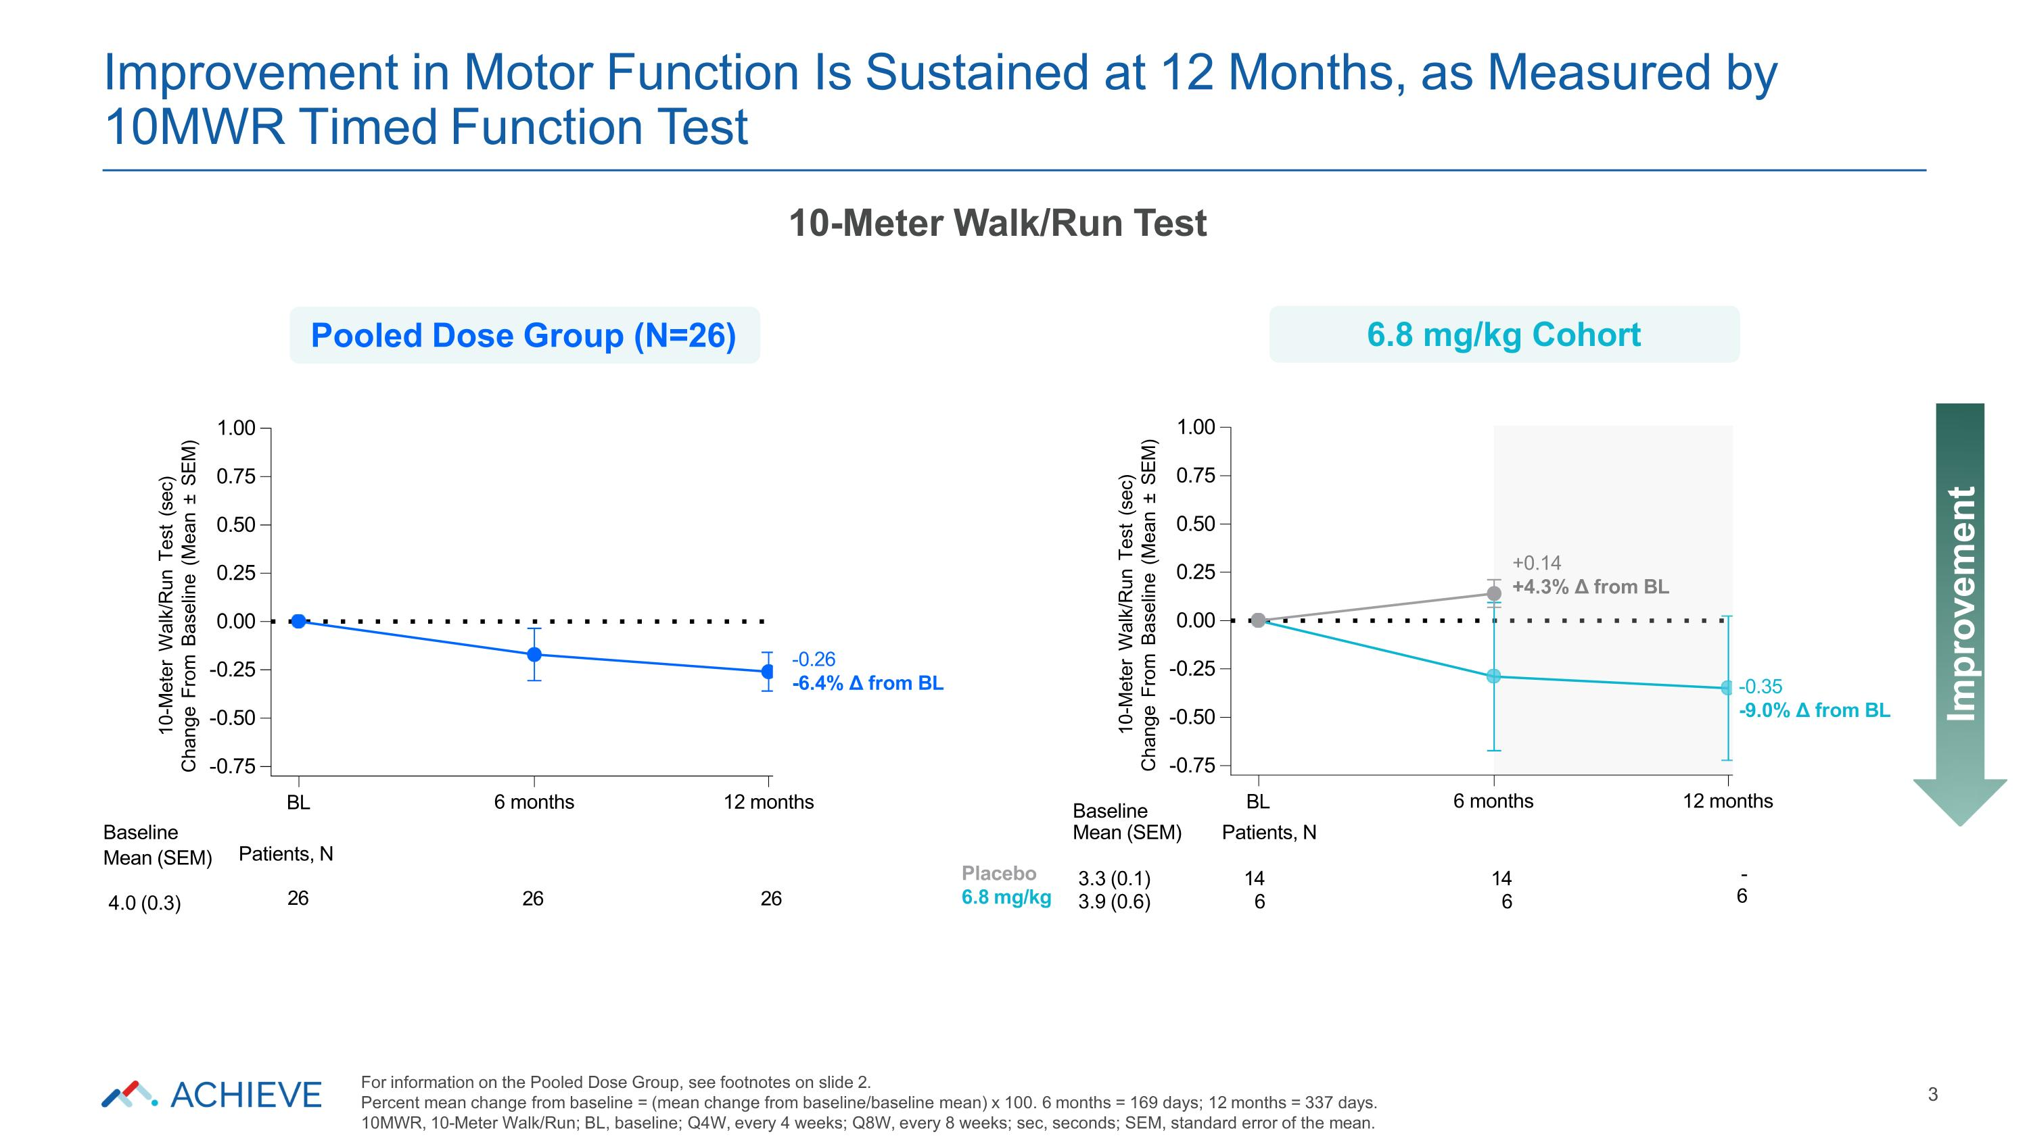
-0.75 -0.50 -0.25 0.00 0.25 0.50 0.75 1.00 10-Meter Walk/Run Test (sec) Change From Baseline (Mean ± SEM) +0.14 +4.3% Δ from BL BL 6 months 12 months Baseline BL 6 months 12 months Baseline Mean (SEM) Patients, N Mean (SEM) 4.0 (0.3) Patients, N 26 26 26 Placebo 6.8 mg/kg 3.3 (0.1) 3.9 (0.6) 14 6 14 6 - 6 -0.35 -9.0% Δ from BL -0.75 -0.50 -0.25 0.00 0.25 0.50 0.75 1.00 10-Meter Walk/Run Test (sec) Change From Baseline (Mean ± SEM) -0.26 -6.4% Δ from BL Improvement in Motor Function Is Sustained at 12 Months, as Measured by 10MWR Timed Function Test 3 Improvement 10-Meter Walk/Run Test Pooled Dose Group (N=26) 6.8 mg/kg Cohort For information on the Pooled Dose Group, see footnotes on slide 2. Percent mean change from baseline = (mean change from baseline/baseline mean) x 100. 6 months = 169 days; 12 months = 337 days. 10MWR, 10-Meter Walk/Run; BL, baseline; Q4W, every 4 weeks; Q8W, every 8 weeks; sec, seconds; SEM, standard error of the mean.

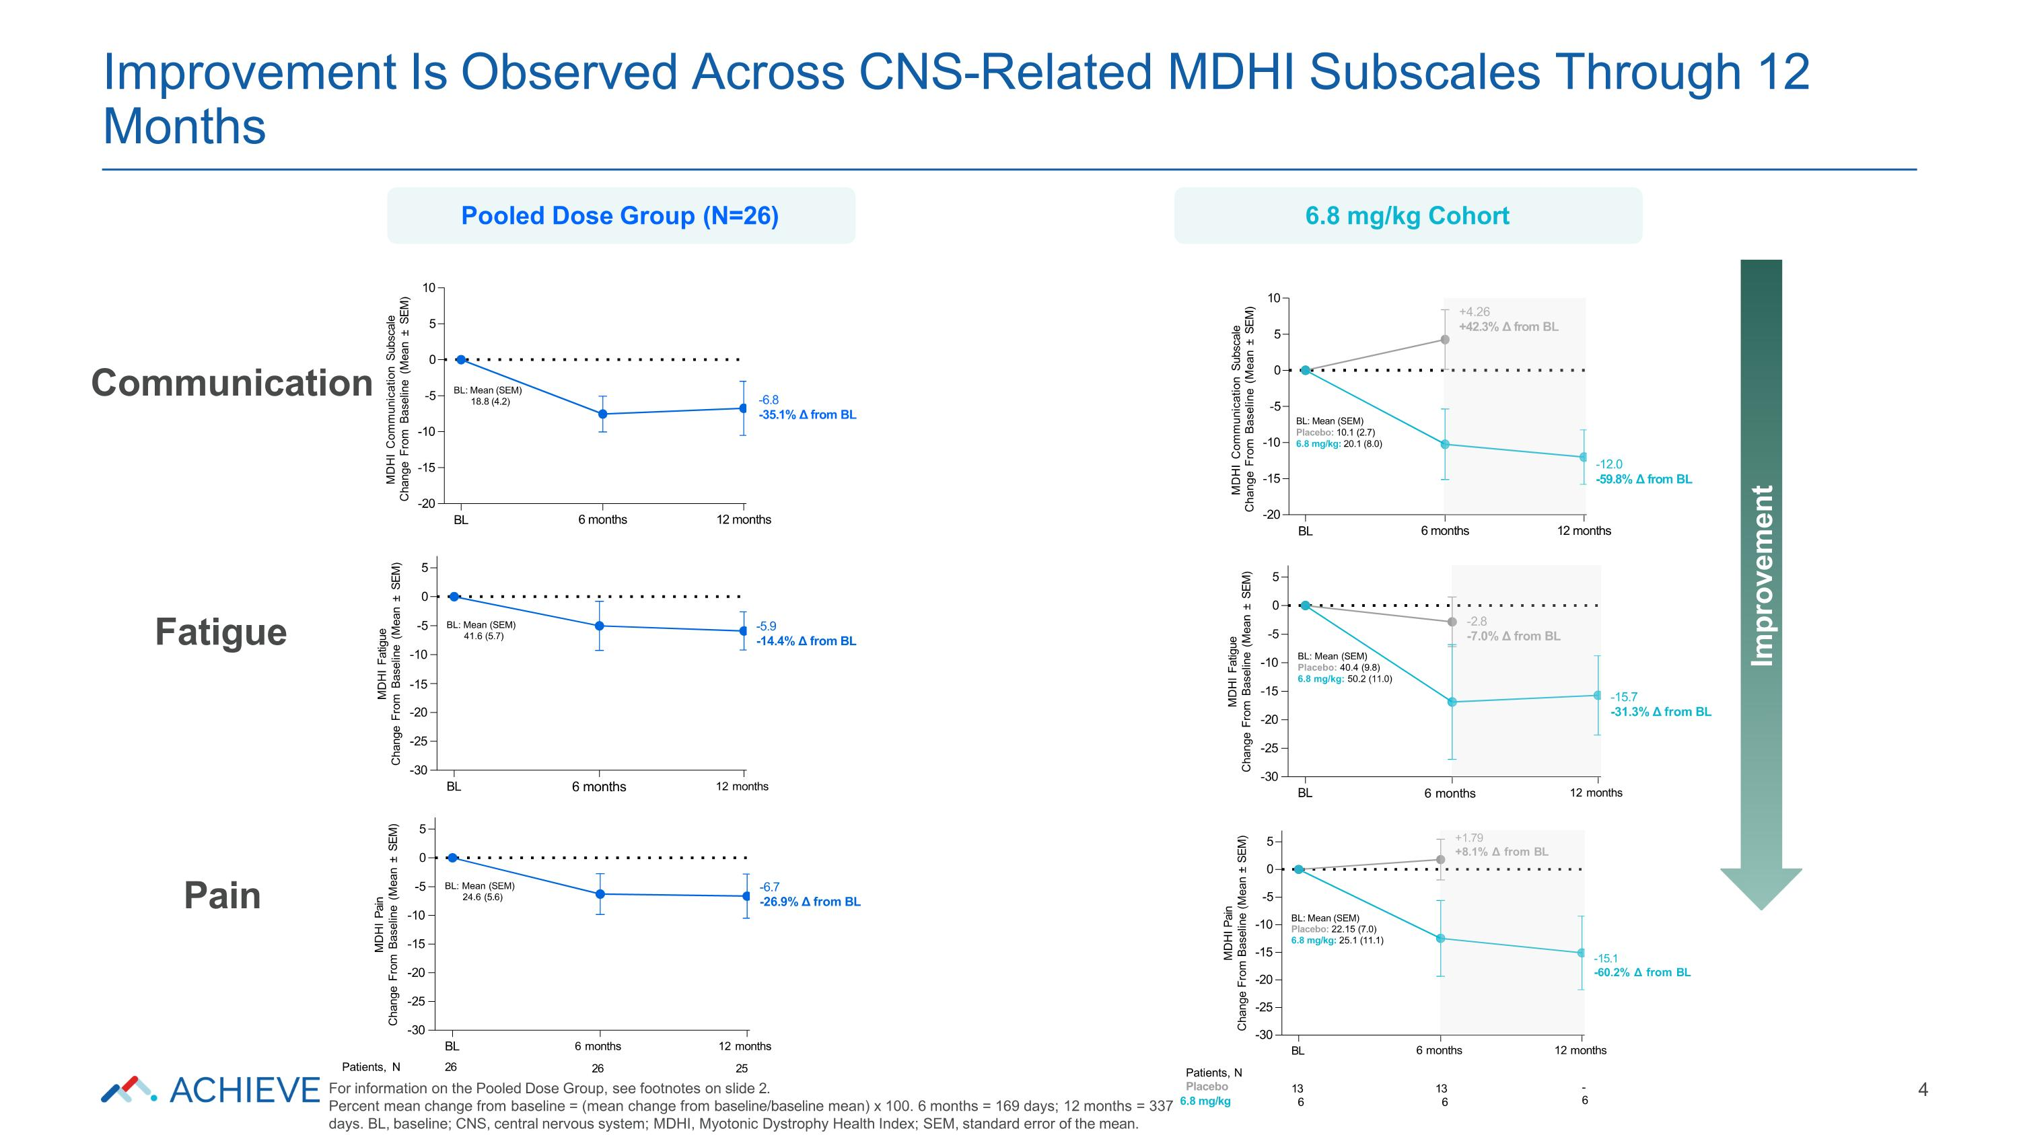
-30 -25 -20 -10 -15 -5 0 5 MDHI Pain Change From Baseline (Mean ± SEM) BL 6 months 12 months -15.1 -60.2% Δ from BL +1.79 +8.1% Δ from BL Patients, N Placebo 13 6 13 6 - 6 BL: Mean (SEM) Placebo: 22.15 (7.0) 6.8 mg/kg: 25.1 (11.1) -30 -25 -20 -15 -10 -5 0 5 MDHI Fatigue Change From Baseline (Mean ± SEM) BL 6 months 12 months -15.7 -31.3% Δ from BL -2.8 -7.0% Δ from BL BL: Mean (SEM) Placebo: 40.4 (9.8) 6.8 mg/kg: 50.2 (11.0) -20 -15 -10 -5 0 5 10 MDHI Communication Subscale Change From Baseline (Mean ± SEM) BL 6 months 12 months -12.0 -59.8% Δ from BL +4.26 +42.3% Δ from BL BL: Mean (SEM) Placebo: 10.1 (2.7) 6.8 mg/kg: 20.1 (8.0) -30 -25 -20 -15 -10 -5 0 5 MDHI Pain Change From Baseline (Mean ± SEM) BL 26 6 months 12 months 26 25 -6.7 -26.9% Δ from BL Patients, N BL: Mean (SEM) 24.6 (5.6) -30 -25 -20 -10 -15 -5 0 5 MDHI Fatigue Change From Baseline (Mean ± SEM) BL 6 months 12 months -5.9 -14.4% Δ from BL BL: Mean (SEM) 41.6 (5.7) -20 -15 -10 -5 0 5 10 MDHI Communication Subscale Change From Baseline (Mean ± SEM) BL 6 months 12 months -6.8 -35.1% Δ from BL BL: Mean (SEM) 18.8 (4.2) Improvement Is Observed Across CNS-Related MDHI Subscales Through 12 Months 4 Improvement Communication Fatigue Pain Pooled Dose Group (N=26) 6.8 mg/kg Cohort For information on the Pooled Dose Group, see footnotes on slide 2. Percent mean change from baseline = (mean change from baseline/baseline mean) x 100. 6 months = 169 days; 12 months = 337 6.8 mg/kg days. BL, baseline; CNS, central nervous system; MDHI, Myotonic Dystrophy Health Index; SEM, standard error of the mean.

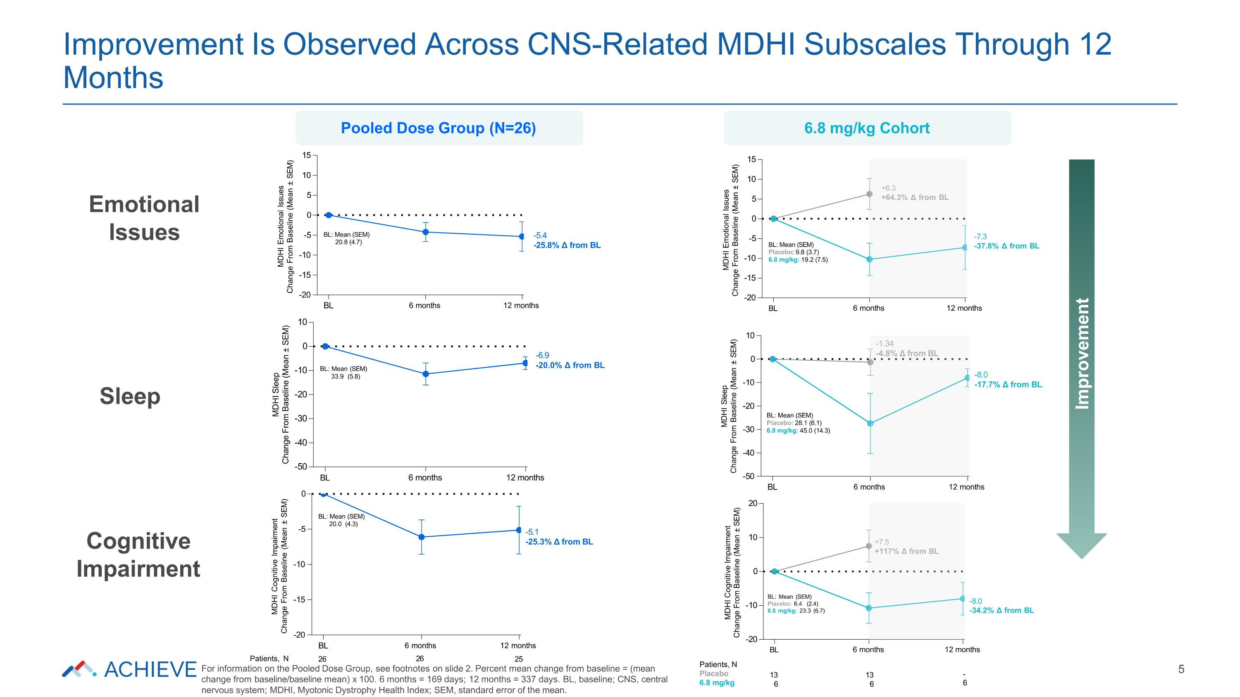
-20 -10 0 10 20 MDHI Cognitive Impairment Change From Baseline (Mean ± SEM) BL 6 months 12 months -8.0 -34.2% Δ from BL +7.5 +117% Δ from BL Patients, N Placebo 6.8 mg/kg 13 6 13 6 - 6 BL: Mean (SEM) Placebo: 6.4 (2.4) 6.8 mg/kg: 23.3 (6.7) -50 -40 -30 -20 -10 0 10 MDHI Sleep Change From Baseline (Mean ± SEM) BL 6 months 12 months -8.0 -17.7% Δ from BL -1.34 -4.8% Δ from BL BL: Mean (SEM) Placebo: 28.1 (6.1) 6.8 mg/kg: 45.0 (14.3) -20 -15 -10 -5 0 5 10 15 MDHI Emotional Issues Change From Baseline (Mean ± SEM) BL 6 months 12 months -7.3 -37.8% Δ from BL +6.3 +64.3% Δ from BL BL: Mean (SEM) Placebo: 9.8 (3.7) 6.8 mg/kg: 19.2 (7.5) -20 -15 -10 -5 0 MDHI Cognitive Impairment Change From Baseline (Mean ± SEM) BL 6 months 12 months -5.1 -25.3% Δ from BL Patients, N 26 26 25 For information on the Pooled Dose Group, see footnotes on slide 2. Percent mean change from baseline = (mean change from baseline/baseline mean) x 100. 6 months = 169 days; 12 months = 337 days. BL, baseline; CNS, central nervous system; MDHI, Myotonic Dystrophy Health Index; SEM, standard error of the mean. BL: Mean (SEM) 20.0 (4.3) -50 -40 -30 -20 -10 0 10 MDHI Sleep Change From Baseline (Mean ± SEM) BL 6 months 12 months -6.9 -20.0% Δ from BL BL: Mean (SEM) 33.9 (5.8) -20 -15 -10 -5 0 5 10 15 MDHI Emotional Issues Change From Baseline (Mean ± SEM) BL 6 months 12 months -5.4 -25.8% Δ from BL BL: Mean (SEM) 20.8 (4.7) Improvement Is Observed Across CNS-Related MDHI Subscales Through 12 Months 5 Pooled Dose Group (N=26) 6.8 mg/kg Cohort Emotional Issues Sleep Cognitive Impairment Improvement

